Information System Implementation in Kakanj Coal Mine

Haris Goralija
International Burch University, Sarajevo, Bosnia and Herzegovina
haris.goralija@live.com

Meliha Handzic
International Burch University, Sarajevo, Bosnia and Herzegovina
mhandzic@ibu.edu.ba

Abstract

The primary aim of this paper is to report a case study of the implementation of an information system in the Kakanj Coal Mine, Bosnia and Herzegovina.
The study examined a variety of aspects pertaining to the information system implementation from the professional and end user perspectives.
Data were collected from the available documentation, and from interviews with the information systems support staff and surveys of employees who were system users.
The collected responses were analyzed using a combination of quantitative and qualitative methods. Due to the time constraint imposed on the authors, only the preliminary qualitative findings are reported here.

Keywords: Information systems (IS), IS implementation, coal mine, case study, Bosnia and Herzegovina

Introduction

Literature has widely recognized the importance of information systems in the mining sector. At the industry level, a web-based one-stop shop information management system was developed to offer invaluable opportunity to share state-of-the-art knowledge for the whole coal mining sector in Australia (Porter et al. 2011). Similar portals are made available by the UK Coal Authority (http://coal.decc.gov.uk/) and by the Indiana Coal Industry in the USA (http://igs.indiana.edu/Coal/).

At the organizational level, information systems are considered valuable for assisting mining businesses in operational decision making (Carter 2006), production management and control (Minfo 2011) and mine safety management (Yang and Song 2010), to mention just a few technical areas of the mine operations. More than that, information systems may play an important role in supporting all primary and secondary activities along the mine’s value chain (Porter, 1985) by providing relevant and trustworthy information where and when needed.

Coal mining represents an important sector of the economy in Bosnia and Herzegovina. With its economic significance on one side and the demanding time constraints, high safety expectations and production goals on the other side, the mining management requires an appropriate information system support to meet these challenges. The purpose of this study is to examine the issue in the leading coal mine in Bosnia and Herzegovina: Kakanj Coal Mine. Specifically, the study will answer the following four research questions:

- How does mine’s information system support organisational business processes?
- Do employees use this system and for what purposes?
- How satisfied are users with their system, service and information it provides?
- Why are some aspects (if any) of the implemented system not in use?

Research Context

The Kakanj Coal Mine is based in the town of Kakanj in Bosnia and Herzegovina. Established in 1902, the mine boasts over a 100-year-old tradition. The company engages in both underground and surface coal mining. It also manufactures and markets briquettes. According to the current information available on the mine’s website (http://www.rmukakanj.ba/onama.php), the company employs 2020 workers distributed in six organizational units.

The existing mine capacities enable the production of 1.2 million tons of coal per year. By investing in further development, this amount can be gradually increased to 1.5 - 2.0 million tons per year. Investment in coal mining is linked directly to modernization and development of production capacities of the Kakanj thermoelectric power facility. By investing in both the mine and the power facility, Bosnia and Herzegovina can ensure a stable production of electric energy in the long term.

The mine’s vision and mission statements emphasize its aimed regional and global positioning in the energy sector; its contribution to local development at the municipal level of Kakanj; its customer-centric business orientation; and knowledge-based business operation. The mine bases its current success and future development on continued improvement of business processes, workplace safety and environmental protection.

As mentioned before, the implementation of an appropriate information system may help the Kakanj Coal Mine in achieving its desired outcomes. Therefore, the following case study will attempt to gain an insight into the mine’s information system implementation by responding to a series of “how” and “why” questions mentioned in the introductory section.

Research Design

A descriptive case study approach was adopted for our investigation in order to gain a deeper understanding of the mine’s information system implementation.

Data were collected from multiple sources including documentation, interviews and survey questionnaires. Since different data sources exhibit different strengths and weaknesses, multiple sources of evidence are recommended to enable triangulation and increase research validity (Yin 1994).

The basic information about the research context was obtained from the mine’s website (http://www.rmukakanj.ba) and from the book entitled Hronika 100 (RMU Kakanj, 2006).

After that, an interview was conducted by researchers with two information systems professionals employed by the mine to operate and maintain the systems and the underlying information and communication technology.

This was followed by an interview with two employees from the accounting department and one employee from the finance department in order to analyses these users’ point of view regarding the quality and usefulness of the mine’s information system. A more extensive survey of a wider pool of users is currently under way.

Finally, another interview is planned after the survey with the mine managers to address any current concerns and future plans.

Following Neuman’s (2011) recommendations, a qualitative analysis of interview data was performed on the basis of descriptions provided of the characteristics of information systems implementation in question. The main findings are reported in the next section. These findings are organized around the four research questions of interest.

Research Findings

How does the mine’s information system support organizational business processes?
The answer to the first research question was obtained from the interviews conducted with two staff members from the information systems support centre. With respect to information and communication infrastructure (ICT), the respondents provided the researchers with a block scheme of the mine have integrated ICT system. This scheme is presented in Figure 1. The figure shows various locations where and how different ICT components are installed and connected in an integrated networked system. Two servers (HPML350 and IBM236) are used for the database (ORACLE) and applications. A mix of cable and wireless links are provided as communication channels. They are presented in full and dotted lines respectively.

Figure 1: Block scheme of ICT infrastructure at Kakanj Coal Mine

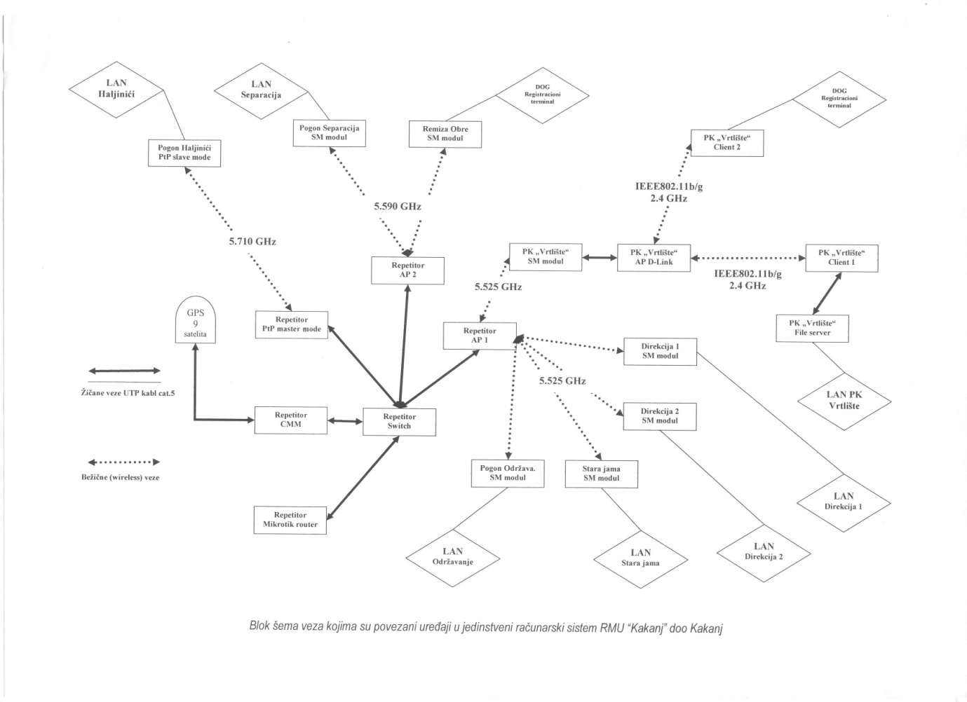
With respect to applications, the two interviewed respondents provided the researchers with a list of modules and sub-modules of POINT 2000, a key information system implemented to support the mine business activities. This list is provided in Table 1. POINT 2000 system is purpose-developed and maintained by a third party. In addition, a series of internally built systems are provided to accommodate specific needs where required.

Table 1: List of POINT 2000 modules with usage indicators

Main modules of POINT 2000 | Usage Indicator
- Metadata | yes
- Accounting and finance | yes
- Commerce – procurement and sales | no
- Management reporting | no
- Assets management | yes
- Human resources | yes
- Administrator | yes

Do employees use this system and for what purposes?

The answer to the second research question was also obtained from the interview with two staff members from the information systems support center. The researchers have been informed that a total of 73 users have access to POINT 2000.

Table 1 shows that five out of seven main modules of POINT 2000 are in use, while two (commerce-procurement and sales; management reporting) are not in use. Table 1 also reveals that the used modules support the majority of secondary activities (i.e. accounting, finance, human resources, ICT) in the mine’s value chain. However, separate systems have been implemented to support the mine’s primary activities.

For example, specific interest, revenue and price calculations for procurement and sales activities are supported by internally developed spreadsheet (EXCEL) applications. Similarly, separate spreadsheet applications are used for dealing with damages (injuries and material) as well as land expropriation and other real estate issues. In production, SCADA is implemented for the miners’ safety management purposes. Given the 1965 mining disaster (RMU Kakanj, 2006), safety is considered of utmost importance. In contrast, the informatization of warehousing is currently excluded from the mine’s consideration.

How satisfied are users with their system, service and information it provides?

To obtain a full answer to this research question, a survey of users is undertaken across the mine’s work units. While survey data collection is still under way, probing interviews were conducted with two employees from the accounting department and one from the finance department. Their opinions are reported here.

Two accounting employees who are POINT 2000 users stated the following: “The system is reliable and fast”; “I get all the information that I need”; “The system offers more functional support than I currently need”; “I am very satisfied with the system”.

A finance employee who is the user of an internally developed spreadsheet application declared the following: “I use a purpose-built spreadsheet program to deal with material and damages from injuries, as well as land expropriation matters”; “I have to use a separate application because POINT 2000 provides only partial support for the mine’s financial activities”.

Why are some aspects (if any) of the implemented system not in use?

The initial answer to this research question was obtained from the interview with two staff members from the information systems support centre. However, another interview is planned with the mine managers in order to get a better understanding of the issue.

For now, we turn our attention to Table 1 that shows two modules of the POINT 2000 system which are not in use. With respect to the commerce module (sub-modules of procurement and sales) the respondents pointed out that the system lacks proper support for the specific mine’s needs. One of the respondents also remarked that “Alternative programs made internally are used instead”.

With respect to the “management reporting” module, the respondents could not understand the reasons for not using it. One of them commented that “It is up to managers to use or not”. At the same time, the same respondent explained that the module offers valuable information that can help in cost reduction and better planning. An interview with the mine managers may offer better insights into potential reasons for their rejection.

An interesting remark was made by one of the interviewed IS professionals regarding the informatisation of warehousing: “Employees in the mine’s warehouses are former miners, often injured ones and with little education. If this activity is automated, these people will lose their jobs”. Since solidarity represents an important characteristic of the mine’s culture, this issue needs careful consideration.

The planned integration of the mine’s information system within the wider SAP supported energy system by the mine’s parent organization “Elektroprivreda” may address this problem within the next two years. It may also attract the mine managers to the highly sophisticated business intelligence and business analytics solutions offered by SAP for managerial decision making support.

Conclusions

The main goal of the case study reported in this paper was to examine various aspects of the information system implementation in the Kakanj Coal Mine, Bosnia and Herzegovina. The main study results provide an insight into the nature, level and success of the implemented system from the IS professional-staff and end-user perspectives. These results also point to several areas that require further consideration and improvement. An encouraging finding is the future plan to integrate the mine’s system into a wider SAP supported energy information system. Future research is recommended in order to provide guidance for smoother transition and further enhancement.

References

Carter, A. W. (2006), Application of Geographical Information System in Underground Coal Mine to assist Operational Management, dissertation, University of Southern Queensland, Faculty of Engineering and Surveying, Australia

Minfo Technologies (2011), Mining Information System: Solution Overview, http://www.minfo-tech.com/MiningInformationSystem.shtml, accessed 13 May 2013.

Neuman, W. L. (2011), Social Research Methods: Qualitative and Quantitative Approaches, 7th ed., Pearson Education, Inc.

Porter, I, Baafi, E and Stace, R. (2011), Development of a Web-based Underground Coal Mining Information Management System, in Proceedings of 11th Underground Coal Operators' Conference, University of Wollongong & the Australasian Institute of Mining and Metallurgy, 10-11 February 2011, 385-389.

Porter, M. (1985), Competitive advantage: creating and sustaining superior performance, The Free Press, New York.

RMU Kakanj (2006), Rudnik mrkog uglja Kakanj: Hronika 100, Dom Stampe, Zenica.

Yang l. and Song M. (2010), Coal Mine Safety Evaluation with V-Fold Cross-Validation and BP Neural Network, Journal of Computers, Vol 5, No. 9, pp. 1364-1371.

Yin, R. (1994), Case study research: Design and methods, SagePublications, Thousand Oaks, CA.

