The Importance of Export Market Diversification Strategy on the Overcoming Economic Crises: The Case of Turkey

Mustafa Göktürk
Mustafa Kemal University, Hatay, Turkey
mgokturk@mku.edu.tr

Tunay Bostan
Mustafa Kemal University, Hatay, Turkey
tbostan@mku.edu.tr

Cemil Serhat Akın
Mustafa Kemal University, Hatay, Turkey
csakin@mku.edu.tr

Abstract

Today, importance of export is increasing at providing and sustaining growth in developing countries. Because of their macro-economic instability and fragility developing countries face to crisis and affected by global economic crisis more than developed countries. At the end of 2007 in USA, problems in returning long-term housing loans created mortgage crisis in financial markets. Crisis spread to all of the markets and return to economic crisis.

Leaping of crisis to developed countries which are economically locomotive of global economy caused crisis spreading and deeding world-wide. The average growth rate of global economy was 5% before the crisis. This rate declined to 3% after crisis (IMF). The crisis affected developing countries by exports. The economic crisis deeply existing in EU countries which are traditionally Turkey Republic’s markets decreasing the share of Turkey to EU exports in the total amount of Turkey exports. The share of Turkey-EU exports was 55% of Turkey’s total export before the global crisis from 1997 to 2008. After the crisis this figure declined 23% in 2009 when the crisis effect was deepest (DTM).

Expectation of the effects of the economic crisis will continue, especially in the EU countries resulted Turkey implementing market diversification strategy in foreign trade. In accordance with the strategy; Turkey performed a group of activities and invested (liaison offices, trade shows, incentives) to rise export focused group of countries especially North Africa and the Near and Middle East country groups.

This paper extends to Turkey’s total export amount to different country groups and rates from 1997 to 2008 accepted as the pre-crisis and from 2010 to 2012 post-crisis period. According to this research the share of Turkey-EU export decreased 11% and became 44%. After implementing market diversification strategy Turkey-MENA export rate increased 10% and became from 13% to 23% (TUİK).

We found that the Turkey’s market diversification strategies succeed and Turkey’s export volume increased. Because of reason Turkey is the one of the countries least affected by global economic crisis and recent global economic uncertainty and recovering the economy fast. Economy of Turkey is the fastest growing economy in Europe. The average growing rate of Turkish Economy is 5,4% from 2002 to 2011. Turkey's economy expanded 8.5% in 2011 (TUİK).

The aim of this study is to show negative effects of economic crisis on growth of economy by the channel of export and to test alternative export policies (market diversification strategy) on recovering crisis.

Keywords: economic crises; export; economic growth; market diversification; Turkey economy

Introduction

For developing countries which creating income with trade of commodities, diversifying exports has long been a policy objective. Today importance of export is increasing at providing and sustaining growth in developing countries. Because of their macro-economic instability and fragility face to crisis and affected by global economic crisis more than developed countries.

At the end of 2007 in USA, problems in returning long-term housing loans created mortgage crisis in financial markets. Crisis spread to all of the markets and return to economic crisis. Leaping of crisis to developed countries which are economically locomotive of global economy caused crisis spreading and deepening world-wide. The outlook of world economy and international trade are unstable. The trade flows are declining and trade shocks are occurring. In this economic outlook for creating income international trade is essential.

2008-2009 global crises and the aftermath of the crisis European debt crisis and the Arab Spring developments will how affect Turkey's economy through the medium and long term is an important research area. Focusing on the new markets and diversification resulted increased the Turkey’s export to Middle East and North Africa. This situation compensate for depression of export to EU countries. After we put the problem in this way it is necessary that determinate the current situation by analyzing Turkish export structure with market divisions and goods.

In this study firstly we review export diversification, trade and economic growth notions. Secondly we aim that to show geographical and sectorial structure of Turkey’s export for 2000-2012 periods. We analyze that importance of Turkey’s target market and sectorial development of export made to target markets by share of geographical divisions and goods on the total export. Lastly we analyze Turkey’s export performance with diversification of geographical divisions and goods.

Export Diversification, International Trade, and Economic Growth

Export growth, export diversification can be positively associated with economic growth. Diversity in exports can reduce income volatility for countries with large populations living in poverty and reduce vulnerability to sharp declines in the terms-of trade. Expanding international trade has been an important avenue for growth in many developing countries. And export diversification is seen by many as an important channel through which trade fuels economic growth: by facilitating improvements in productivity, by capturing economies of scale, and by curbing volatility (Newfarmer, et al, 2009).

Export diversification, growth, and volatility and its impact on economic growth is as old as economic development literature. But the literature does not come up with a consistent definition of export diversification. A general definition of diversification of exports is chancing the country's current product mix or changing in the number of export markets. There are three dimensions of diversification: breaking into new geo Figure markets, improving the quality of existing exports, increasing services exports.

A more useful definition is originated from the way diversification is measured. It is preferred to use the concentration indices to measure the extent to which country’s export is diversified. The concentration indices measure whether majority of country’s export earnings comes from small range of export products (indication of export concentration) or the source of export earnings are more evenly spread across a given range of export goods (indication of export diversification).

Export can grow at the intensive (the growth in the value of existing products) and extensive margin (the increase in the number of export lines). Accordingly, export diversification can be captured along the margins: a more evenly spread of the export basket is an indication of diversification at the intensive margin, while the greater number of export lines indicate diversification at the extensive margin (Cadot et al., 2009).

The biggest differentiation is made between horizontal and vertical diversification. Horizontal diversification entails alterations or balance of the export mix – more of an existing commodity is being produced to meet increased export demand for this commodity. Vertical diversification involves contriving further use for existing products by means of adding value or introducing new products for which the country had no prior export experience. Both dimensions are reflected in above index. In addition, export diversification can take place by marketing products to new destinations or increasing the export volume in previously under-served markets. All of forms and dimensions are associated with economic gains.

While definition of intensive margin is similar in majority of studies, different authors define extensive margin differently. In our definition, extensive margin is, as in Melitz (2003), new product margin. Besides, the literature argue that diversification of exports on the extensive margin could be achieved along geographical dimension (when a product, either the existing or a new one, is exported to new markets) and along quality dimension (by improving the quality of existing products). Such measures of geographical diversification at the extensive margin can be found in Breton and Newfarmer (2007), Amurgo-Pacheco and Pierola (2007) and some others. It is not uncommon in empirical studies that export diversification is identified as extensive margin. Diversification on the intensive margin of export growth is not investigated much in the literature. In that sense, our focus on factors that affects diversification at the intensive margin is the novelty in this literature.

In order to assess the extent of export diversification, diversification-related empirical literature usually takes concentration measures from the literature on industrial organization and inequality measures from the income inequality literature. The concentration and inequality indices (Herfindhal, Gini and Theil indices in particular) seem to be the most widely used measures of export diversification. Concentration indices measure changes in a country’s export structure, defined at any level of aggregation. However, the measure is better if the data are at a greater level of disaggregation (Cadot et al., 2009). Indices are cumulative or summary measures of concentration as they explain the entire size distribution of exports and allow the value of the index to be influenced by changes in every part of the distribution

Export diversification aims at moving away from a limited basket of exports in order to mitigate economic and political risks of dependence upon a few primary commodity exports. When export is concentrated in a few primary commodities, there can be serious economic and political risks. Economic risks include: in the short term, volatility and instability in foreign exchange earning which have adverse macroeconomic effects (on growth, employment, investment planning, import and export capacity, foreign exchange cash flow, inflation, capital flight and undersupply of investments by risk averse investors, debt repayment); and in the long term, secular and unpredictable declining terms of trade trends which exacerbate short run effects. Political risks include worsened governance and risk of civil war in fragile states; as recent research (Collier, 2002) shows that primary commodity dependence is associated with various dimensions of poor governance; and the risk of conflict is strongly related to the level and growth of income, as well as its structure as reflected in the dependence upon a few primary commodity exports. Heavy dependence on a small number of primary commodity products exposes a country to the negative effects of unfavorable characteristics of world demand and negative supply side features of these primary products.

On the demand side, the low income elasticity of world demand of primary commodities can lead to falling export revenues which can be exacerbated by historically downward trends in primary commodities relative to manufactures. Although, according to Cashin and Mc. Dermott (2002), real commodity prices have declined by about 1% per year over the last 140 years, volatility and persistence of commodity price shocks can have more dramatic consequences than the long term downward trend of commodity prices. On the supply side, the combined effect of lower skills and technology content of commodity production and its negligible backward and forward linkages with the rest of the economy usually lead to negative growth spillovers (Samen, 2010).

A diversified portfolio could help minimize volatility in export earnings and boost overall growth by replacing primary commodities with positive price trends products and adding value through additional processing or marketing. As traditional exports are particularly vulnerable to exogenous shocks and face limited demand due to their low income elasticity and declining terms of trade, diversifying away from traditional exports is expected to raise growth rates and lower their variability. Hence, export diversification can also aim at improving backward and forward linkages to domestic inputs and services, and expanding opportunities for export in existing or new markets. Reducing dependence upon one or a limited number of geo Figureal destinations or origins can also be a major objective for export diversification (Samen, 2010).

As an example, Değer (2010) found a statistically significant relationship between the of Turkey's economy data for the period 1980-2006 with long-term economic growth and export diversification. He demonstrated that manufactured goods weighted export structure and export goods diversification both have a positive effects on Turkey’s economic growth. Similarly, Aldan et al (2012) point out that Turkey has diversified her exports by sector as well as by markets in 2003-2011 period. They gave a detailed analysis of export diversification by sectors within markets and by markets for different sectors. The results suggest that market diversification has been increased in main export sectors such as machinery and transportation, iron and steel, wearing apparels and textiles. Similarly, product diversification has been increased in main export markets such as EU, Middle East and North America. These findings indicate that Turkish exports have gained strength against external shocks observed for particular sectors and/or markets.

Structural Change in Exports and Export Diversification: A Look at TURKEY over the Period 2003–2011

Turkey's ties with the global economy have increased rapidly after 2001economic crisis. The successful implementation of stabilization and structural reform program and the positive situation in the world economy contributed to the emergence of this table. Turkey’s import volume annual average increase rate come from 11 percent in the 1991-2000 periods to 31 percent in the 2002-2008 periods. After 2001 not only the volume of imports the volume of export has grown rapidly. Export volume in the period 2002-2007 average annual growth rate increased to 30 percent from 8 percent in the 1991-2000 periods. (Acar, 2009)

According to Figure 1; In 2001, the Gross Domestic Product (GDP) decreased by 5.7% compared to the previous period, Turkey's economy, the first quarter of 2002 to the third quarter of 2008, the average term of 6.5% and a growth process which lasted a full 27 quarters into a row. With the 2001 crisis in the first place companies have focused to foreign markets as a result of the contraction in domestic demand and the depreciation of the Turkish Liras. Between from 2001 crisis to the 2008 crisis (2002 - 2007 period and the first two quarters of 2008), the importance of foreign trade in economy increase with the worl markets demand increase and increasing competition in the domestic market with the disinflation process (Aysan/Hacıhasanoğlu 2007; Aydın et. al., 2007; Yükseler/Türkan, 2008).

Figure 1: Average Annual Real GDP Growth (%) 2002-2011

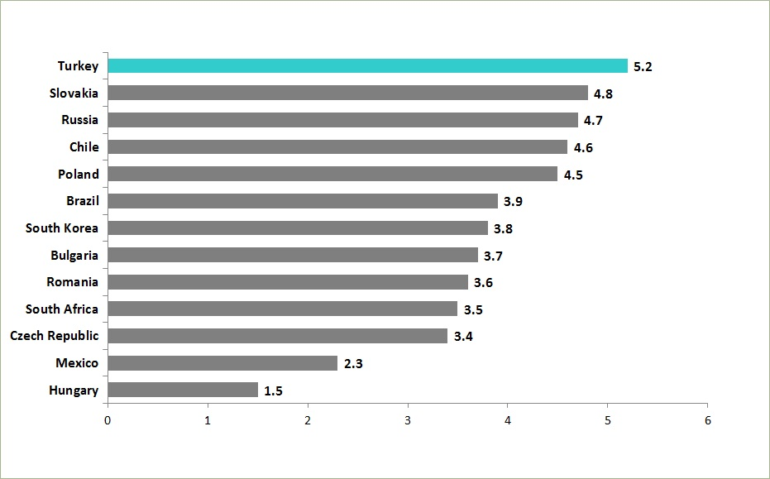
Source: IMF World Economic Outlook April 2012, Turkish Statistical Institute (TurkStat)

Together with stable economic growth, Turkey has also reined in its public finances; the EU-defined general government nominal debt stock fell to 39.4 percent from 74 percent in a period of nine years between 2002 and 2011. Hence, Turkey has been meeting the “60 percent EU Maastricht criteria” for public debt stock since 2004. Similarly, during 2002-2011, the budget deficit decreased from more than 10 percent to less than 3 percent, which is one of the EU Maastricht criteria for the budget balance. (Turkey Economy Ministry, 2013)

As the GDP levels more than tripled to USD 772 billion in 2011, up from USD 231 billion in 2002, GDP per capita soared to USD 10,444, up from USD 3,500 in the given period. The visible improvements in the Turkish economy have also boosted foreign trade, while exports reached USD 135 billion by the end of 2011, up from USD 36 billion in 2002. Similarly, tourism revenues, which were around USD 8.5 billion in 2002, exceeded USD 23 billion in 2011 (Turkey Economy Ministry, 2013).

Significant improvements in such a short period of time have registered Turkey on the world economic scale as an exceptional emerging economy, the 16th largest economy in the world and the 5th largest economy when compared with the EU countries, according to GDP figures (at PPP) in 2011. While many economies have been unable to recover from the recent global financial recession, the Turkish economy expanded by 9.2 percent in 2010, and 8.5 percent in 2011, thus standing out as the fastest growing economy in Europe, and one of the fastest growing economies in the world (Figure 2).

The global financial crisis of 2008, has lead Turkey's foreign trade partners to economic depression. As a general fact through foreign trade channel global crisis can be penetrate in Turkey. The initial effects of the global financial crisis, which is Turkey's most important trading partner in the EU countries has rapidly, become visible. Growth rates of Turkey's most important trading partners after 2008 were well below the growth rates experienced between 2002 and 2007 (Figure 2).

Figure 2: GDP Growth (%) 2005-2014

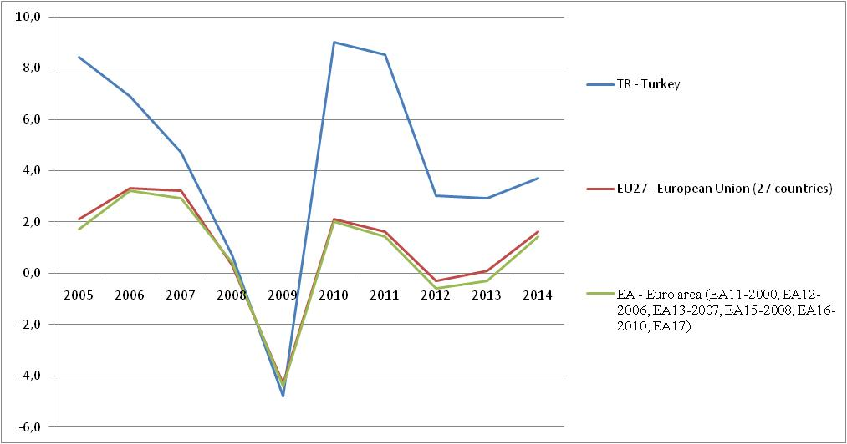
Source: Eurostat
Note: Unit: Percentage change on previous period (PCH_PRE)
Indicator: Gross Domestic product at market prices

We see that in the period of 2001-2012 there is rapid increase in the total export amounts of Turkey. The break of this time series is in 2009. From 2001 to 2008 turkey total export raised 4,2 times. The highest growth rate (33,1) was in 2004. After 2008 there was a global crisis and that cause decrease in foreign trade flows. In 2009 total export growth change rate decrease from 23,1 to minus 22 percent. From 2010 Turkey implied export market diversification. And Turkey recovered the total export, 2012 figure was 152 536 653 000 (US Dollars) (Figure 3; Figure 4)

Figure 3: Turkey’s Total Export

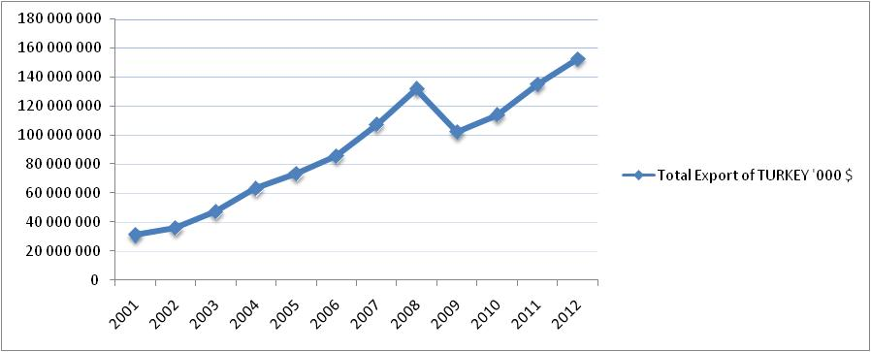
Source: TUİK, 2013

Figure 4: Turkey’s Total Export Growth

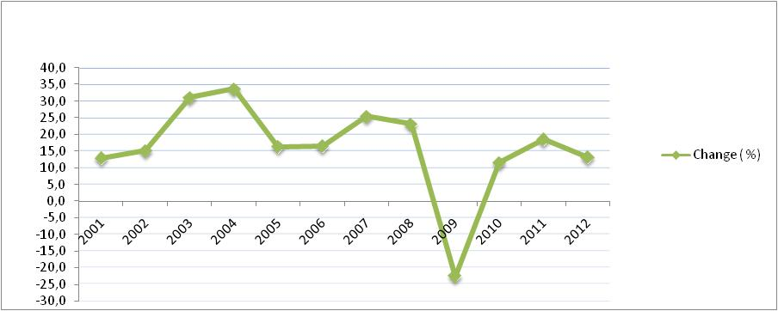
Source: TUİK, 2013

EU has the biggest share on the Turkey’s Export. After the 2008 global crisis the share of EU on Turkey’s export decrease but EU still the important export partner of Turkey. 2008 global crisis effected all partners of Turkey especially export to North America decreased 50% percent after crisis (TUİK, 2013). After the Turkey changed export policy, the share of exports to Middle Eastern countries began to increase again, the effects of the global financial crisis started to be felt in 2008 has reached remarkable proportions. North Africa and Mena country groups has relatively low share on the Turkey’s Export but after crises they became more important for Turkey (Figure 6, Figure 7, and Figure 8).

Turkey's export volume growth rate is analyzed on a regional basis we see that cause of the decrease in export growth is Economic recession in the EU countries. The global financial crisis hit the EU countries with the October 2008-January 2009 period, the growth rate of Turkey’s exports to the EU countries, began to decline rapidly. Deterioration in export performance is not limited with EU countries. In addition, Turkey's exports to other European countries caught in the growth rate of 37 per cent pre-crisis, has declined by -1 percent after crisis Turkey can increase export to only North African countries (Table 1; Figure 6)

Turkey exports to EU countries mainly textile, clothes, machinery and transporting vehicles. In Turkey's exports to this region in 2003 the share of machinery and transporting vehicles has equal shares. After 2008 this equilibrium seems to have changed decisively in favor of machinery and transporting vehicles. New countries such as China and India got more importance in textile and clothing sector, Turkey export rates in these sectors decreasing parallel. The important point is the most serious deterioration is in the automotive and communication equipment sectors which require specialty in manufacturing of consumer goods. Turkey has an important role in these sectors global value chains. İt is possible that contraction in the production of these sectors value chain would be serious repercussions for all global value chain. Based on these data Turkey’s export getting more intense in North Africa and Europen countries (nonmembers of EU). We can neglect the raise of export to Europen countries (nonmembers of EU) in 2008-2009 periods. After the rapid change in the year 2004, there nothing change first 10 sector shares but first 5 sector shares decrease little. When we study both of first 5 sector shares and first 10 sector shares, export intensive in North America market is regressing seriously (Figure 5).

Figure 5: Sectorial and geographical distribution of Turkey's Export

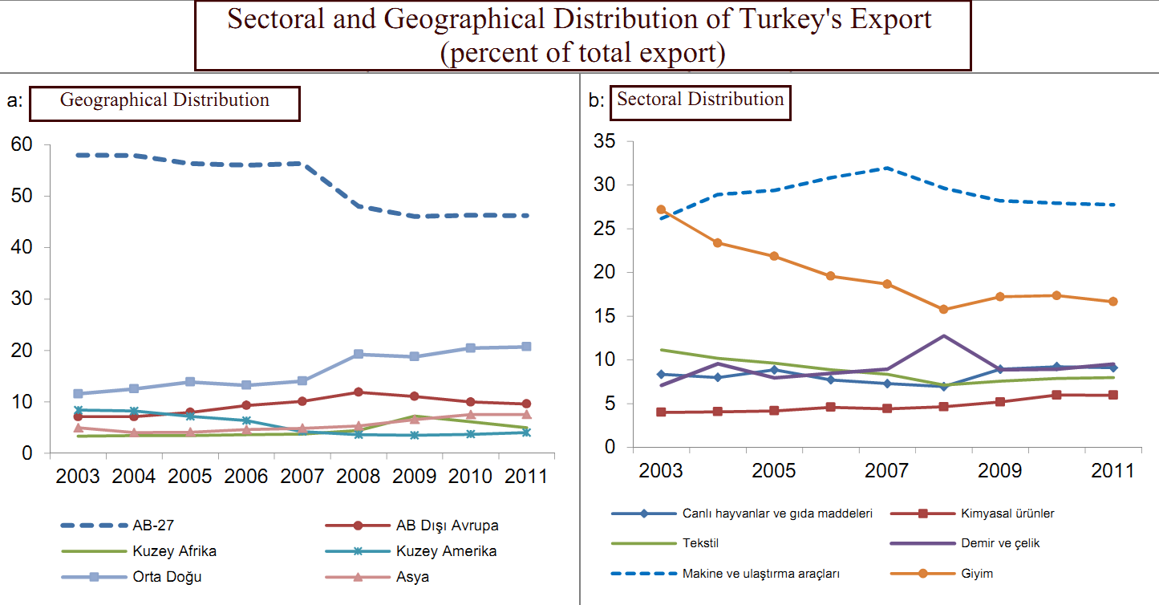
Source: (Aldan et.al. 2012); (TUİK)

Figure 6: Turkey’s Total Export to EU (27) Countries

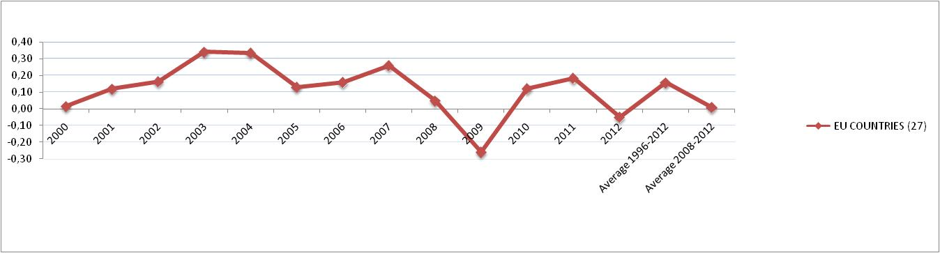
Source: (TUİK, 2013)

Figure 7: Turkey’s Total Export to Africa

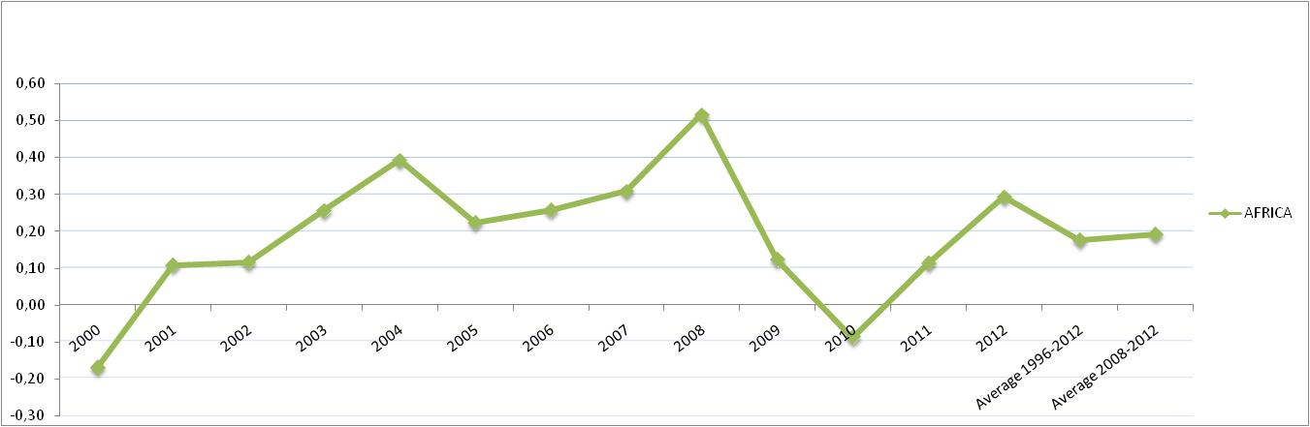
Source: (TUİK, 2013)

Figure 8: Turkey’s Total Export to Middle and Near East

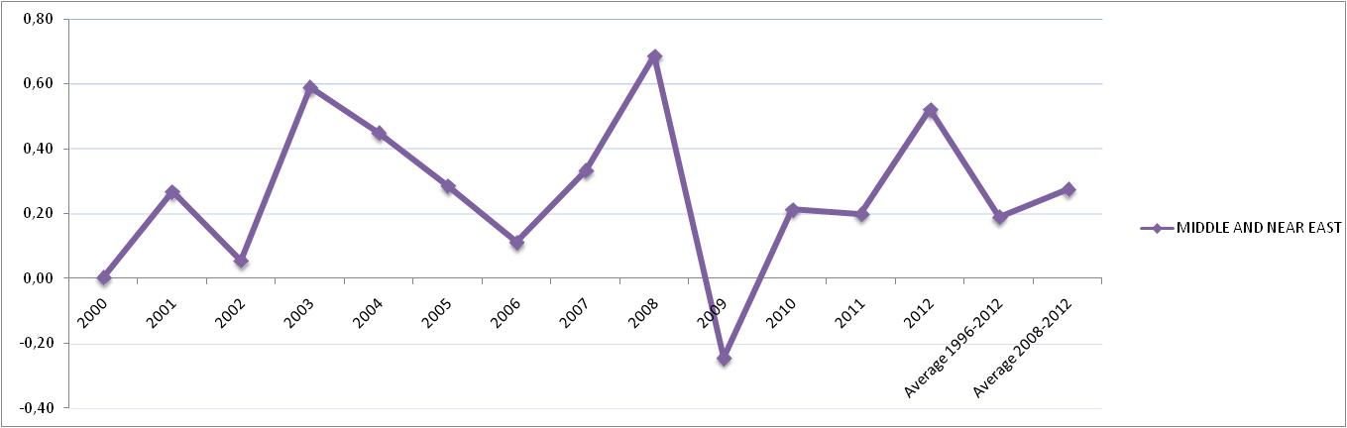
Source: (TUİK, 2013)

Table 1: Turkey’s Total Export by Country Groups

TOTAL EXPORT | 2000 | 2001 | 2002 | 2003 | 2004 | 2005 | 2006 | 2007 | 2008 | 2009 | 2010 | 2011 | 2012
 | 27.775 | 31.334 | 36.059 | 47.253 | 63.167 | 73.476 | 85.535 | 107.272 | 132.027 | 102.143 | 113.883 | 134.907 | 152.561
A- EU COUNTRİES (27) | 15.664 | 17.546 | 20.415 | 27.394 | 36.581 | 41.365 | 47.935 | 60.399 | 63.390 | 46.977 | 52.685 | 62.347 | 59.241
B- FREE TRADE ZONES | 895 | 934 | 1.438 | 1.928 | 2.564 | 2.973 | 2.967 | 2.943 | 3.008 | 1.957 | 2.084 | 2.545 | 2.295
C- OTHER COUNTRİES | 11.216 | 12.854 | 14.206 | 17.931 | 24.022 | 29.137 | 34.633 | 43.930 | 65.622 | 53.208 | 59.114 | 70.015 | 91.025
1- Europe Countries (Non EU members) | 1.855 | 2.094 | 2.607 | 3.362 | 4.507 | 5.855 | 7.962 | 10.843 | 15.678 | 11.359 | 11.373 | 12.976 | 14.373
2- Africa | 1.373 | 1.521 | 1.697 | 2.131 | 2.968 | 3.631 | 4.566 | 5.976 | 9.063 | 10.180 | 9.283 | 10.334 | 13.361
North Africa | 1.087 | 1.150 | 1.267 | 1.577 | 2.203 | 2.544 | 3.097 | 4.030 | 5.850 | 7.445 | 7.025 | 6.701 | 9.448
Other Afrika Countries | 285 | 371 | 430 | 554 | 765 | 1.087 | 1.469 | 1.947 | 3.212 | 2.735 | 2.258 | 3.633 | 3.913
3- AMERİCA | 3.596 | 3.685 | 3.914 | 4.269 | 5.733 | 5.960 | 6.328 | 5.603 | 6.532 | 4.836 | 6.078 | 7.926 | 9.636
South Amerika | 3.309 | 3.297 | 3.596 | 3.973 | 5.207 | 5.276 | 5.439 | 4.541 | 4.802 | 3.561 | 4.242 | 5.459 | 6.673
Middle America | 167 | 201 | 197 | 166 | 334 | 411 | 548 | 549 | 829 | 597 | 598 | 626 | 770
South America | 120 | 186 | 121 | 131 | 193 | 274 | 341 | 514 | 901 | 678 | 1.237 | 1.840 | 2.193
4- ASİA | 3.871 | 4.592 | 5.230 | 7.813 | 10.465 | 13.213 | 15.257 | 20.309 | 32.505 | 25.912 | 31.876 | 38.134 | 53.059
Middle ve Near East | 2.573 | 3.261 | 3.440 | 5.465 | 7.921 | 10.184 | 11.316 | 15.081 | 25.430 | 19.208 | 23.295 | 27.935 | 42.477
Other Asian Countries | 1.298 | 1.331 | 1.790 | 2.348 | 2.544 | 3.029 | 3.942 | 5.227 | 7.074 | 6.704 | 8.581 | 10.199 | 10.582
5- AVUSTRALİA and NEW ZELAND | 135 | 98 | 122 | 158 | 264 | 271 | 327 | 343 | 435 | 360 | 403 | 481 | 490
6- Other Countries | 385 | 864 | 637 | 197 | 84 | 208 | 192 | 857 | 1.410 | 561 | 102 | 164 | 105

Source: TUİK 2013

Conclusion

In this study firstly we review export diversification, trade and economic growth notions. Secondly we aim that to show geographical and sectorial structure of Turkey’s export for 2000-2012 periods. We analyze that importance of Turkey’s target market and sectorial development of export made to target markets by share of geographical divisions and goods on the total export. Lastly we analyze Turkey’s export performance with diversification of geographical divisions and goods.
First, we found that export to EU countries which are Turkey’s traditional export markets, decreasing due to lack of demand. Turkey focused on historically and geographically near countries North Africa and MENA countries. Turkey total export is growing after this diversification policy. But we use average and total amounts of relatively short period (2000-2012) our data supports the main idea of “diversification of export markets policy helps to cope with economic crises”.

References

Acar, O. (2009). Türkiye’de Dış Ticaret ve Dış Ticaretin Finansmanı Durum Değerlendirmesi, TEPAV Raporu,

Aldan A., Aydın M.F., Çulha O.Y., Sunel E., (2012). İhracatta Bölgesel ve Sektörel Çeşitlenme, TC Merkez Bankası Sayı: 2012-18

Amurgo-Pacheco, A. and Pierola, M.D. (2007). Patterns of Export Diversification in Developing Countries: Intensive and Extensive Margins. Economics Section, The Graduate

Aydın F., Saygılı H., Saygılı M., (2007). Empirical Analysis of Structural Change in Turkish Exports, Research and Monetary Policy Department Working Paper (No: 07/08) (Ankara: The Central Bank of the Republic of Turkey).

Aysan A.F., Hacıhasanoğlu Y.S., (2007). Investigation on the determinants of Turkish Export-Boom in 2000s, The Journal of International Trade and Diplomacy, 1/2: 159- 202.

Brenton, P., and Newfarmer, R. (2007). Watching More than the Discovery Channel: Export Cycles and Diversification in Development Unpublished. World Bank, Washington, D.C.

Cadot, O., Carrère , C., Strauss-Kahn V. (2009). Export Diversification: What's behind the Hump?. Review of Economics Retrieved April 25 2013, from http://hal.archives-ouvertes.fr/docs/00/55/69/99/PDF/2007.24.pdf

Collier, P. (2002). Primary Commodity Dependence and Africa’s Future,World Bank Retrieved April 25 2013, from http://siteresources.worldbank.org/D EC/Resources/84797-1251813753820/6415739-1251814045642/Collier-full.pdf Institute of International Studies. HEI Working Papers 20-2007.

Melitz, M. J. (2003). The Impact of Trade on Intra-Industry Reallocations and Developing Countries: Intensive and Extensive Margins. Economics Section, The Graduate Export Cycles and Diversification in Development. Unpublished. World Bank, Washington, D.C.

Newfarmer Richard , Shaw William, Walkenhorst Peter. (2009).”Breaking into new markets : emerging lessons for export diversification “World Bank, Washington, D.C.

SAMEN S., (2010). Export development, diversification, and competitiveness: how some developing countries got it right. Unpublished. World Bank. (P;3-4)

Turkey Economy Ministry Retrieved April 25, (2013). From http://www.invest.gov.tr/en-us/turkey/factsandfigures/pages/economy.aspx

Yükseler Z., Türkan E., (2008). Türkiye’nin Üretim ve Dış Ticaret Yapısında Dönüşüm (İstanbul:Türk Sanayicileri ve İşadamları Derneği (TÜSİAD) Yayını).

