Bilingualism in Kuwait – a linguistic landscape approach

Original research paper

Amna Brdarević Čeljo¹, PhD | Sead Zolota²
¹ International Burch University, Sarajevo B&H | ² Kuwait Academy Bilingual School, Riggae, Kuwait
amna.brdarevic.celjo@ibu.edu.ba | sead.zolota@gmail.com

Article History
Submitted: 15 January 2019
Accepted: 10 February 2019

Abstract: This paper examined the linguistic landscape of the Governorate of Farwaniya, the biggest governorate in the State of Kuwait, by means of public and private signs displayed in the city center and side streets. A corpus of 150 photos of diverse signs, both official and non-official, was collected, categorized, analyzed and discussed. The results point to an undeniable representation of the Arabic language in both public and private spheres of life as well as to a substantial presence of the English language on a wide range of signage therefore confirming the imprint the process of globalization has made on this EFL context. The findings also indicate that some other world languages, namely Bengali, Hindi, and Chinese, are represented in the linguistic landscape of Kuwait but rather poorly.
Keywords: linguistic landscape, monolingual and multilingual signs, official and non-official signs, ethnolinguistic vitality

- Introduction

In the modern day and age, we are constantly surrounded by a maze of intricate signage, whether it is a street sign, a shop sign, an advertisement, or a graffiti. The most frequent manifestation of a sign takes the shape of a written message, an image, or in most cases, a combination of both. Their display, content, location, and context constitute the concept of linguistic landscape and they represent the main investigatory data from which information about the linguistic and socio-political context of a country in question can be drawn. The field of linguistic landscape focuses on studying representations of language in public spheres of human life, which may include any visible signs, people`s perception of it, and how they interact with it. With the process of globalization in full swing and the ideologies of multilingualism and multiculturalism firmly rooted in different countries around the world, this field has attracted the attention and intense interest of researchers in different disciplines, such as sociolinguistics, sociology, linguistic anthropology, politics, semiotics, and urban studies.

The term linguistic landscape has been contested and some other terms have been proposed, namely “the decorum of the public life” (Ben-Rafael, Shohamy, Amara & Trumper-Hecht, 2006, p. 10), the “environmental print” (Huebner, 2006, p. 33-35) and a “multilingual cityscape” (Gorter, 2006, p. 2). In all the aforementioned proposals, the notion of landscape has been avoided due to the fact that the term landscape denotes a large area of the countryside or “a painting depicting a scenery on land” (Gorter, 2006, p. 83) whereas the main focus of this field is actually a public, urban area. In addition to this, the term linguistic has also been found problematic since, as Jaworski and Thurlow (2010) maintain, linguistic is only one of the elements for the construction and interpretation of a place as the written discourse always “interacts with other discursive modalities: visual images, nonverbal communication, architecture, and the built environment” (Jaworski & Thurlow, 2010, p. 2). Still, as the notion of linguistic landscape has been widely accepted and frequently used by many researchers in the field (e.g. Backhaus, 2005; Ben-Rafael et al., 2006; Huebner, 2009; Landry & Bourhis, 1997) it is employed as such in the current paper.

Linguistic landscape (LL) is described as “the language of public road signs, advertising billboards, street names, place names, commercial shop signs, and public signs on government buildings [that] combines to form the linguistic landscape of a given territory, region, or urban agglomeration” (Landry & Bourhis, 1997, p. 25) or as a language on the objects in the public space (Ben-Rafael et al., 2006). It determines and clarifies which languages are most prominent and particularly valued in the public and private spheres and “indexes the social positioning of people who identify with particular languages” (Dagenais et al., 2009, p. 254). Shohamy and Gorter (2009, pp. 1-2) believe that the prime focus of LL research is language in the immediate environment, namely words as well as images displayed in public spaces and they associate the LL with language that is visible and can be observed in schools, buses, government buildings, cities, etc. Thus, analyzing the language displayed in the researched context, the context itself, people identifying with that language as well as messages conveyed is the core of LL research.

Researchers in the field of linguistic landscape gather data on language displayed in public spaces by visiting different geographical sites which they believe might contain interesting information on the (socio)linguistic or socio-political situation. Thus, some studies focused on the analysis of main streets or shopping streets (Blackwood & Tufi, 2015; Cenoz & Gorter, 2003) or researched the surrounding of a public transport route (Backhaus, 2007), while others focused on advertising billboards (Tulp, 1978) or shopping malls (Trumper-Hecht, 2009). As mentioned earlier, the main investigatory data in this field are signs from the environment performing different functions. The purpose and location of signs play a vital role in their interpretation and we distinguish them based on their function and the context in which they are displayed. According to Chandler (2002, p. 4) signs “take the form of words, images, sounds, odors, flavors, acts or objects, but such things have not intrinsic meaning and become signs only when we invest them with meaning”. Chandler (2002) emphasized that something represents a sign when it is interpreted as a signifier of something “referring to or standing for something other than itself” (p. 4). Scollon and Scollon (2003) state that there are three different ways a sign can have a meaning in semiotic theory. Firstly, the sign can be a picture of something in the environment and it is called an icon. Secondly, it can be a random representation of a thing in the world and it is called a symbol and thirdly, a sign has a meaning because of the place and time it is located in and it is called an index.

Signs have been classified in various ways. Heubner (2009) focused on the purpose a sign has in the linguistics landscape and proposed that signs be classified as informational, interactional, directive, expressive, and poetic, which emphasizes the importance of the function of a sign. Likewise, Landry and Bourhis (1997) also attached great importance to the function of a sign and the function of the linguistic landscape of a territory in general and they stated that the linguistic landscape of a territory can have two different functions, namely informational and symbolic. Thus, the linguistic landscape serves to inform “in-group and out-group members of the linguistic characteristics, territorial limits, and language boundaries of the region they have entered” (Landry & Bourhis, 1997, p. 25). However, Landry and Bourhis (1997) also point out the symbolic function of a sign and state that signs can emotionally and ideologically impact the members of the linguistic landscape in which these signs are displayed. Thus, the absence of a language on public signs certainly affects the feelings of the members of that language group in a setting featuring more than one language (Bourhis, 1992).

Signs, such as traffic signs, may inform us or contain a warning notice we should heed, whereas other signs may display names of government institutions or product advertisements providing us with information which is in accordance with our interest. Based on the type of the information signs provide, they can be classified into private signs and government signs (Landry & Bourhis, 1997; Leclerc, 1989). Private signs are non-official and they are commercial signs on shops and other businesses, commercials on billboards, advertising signs in public transport system and individual cars (Landry & Bourhis, 1997). On the other hand, government signs are road signs, street names, names of different governmental institutions etc. Additionally, Ben-Rafael et al. (2010) rely on this classification providing different names for public and government signs. Thus, they classify signs as top-down and bottom-up, whereby top-down or official signs designate government signs while bottom-up or non-official signs designate private signs. In this division of signs, there exists an ambiguous area related to the discrepancies in the design of official and non-official signs due to a substantial difference between them. That particular area was scrutinized by Huebner (2009, p. 74), who claimed that “the distinction between `top-down` versus `bottom-up` failed to capture the notion of agency and how it impacted language forms in the linguistic landscape”.

Official or government signs are frequently translated into some widely spread world languages mainly for the purpose of ensuring that tourists and foreigners who visit the country can read them and because of the language policy in the country (Backhaus, 2006), though there are still some official signs which are left untranslated. As for non-official or private signs, their translation depends on the owners of the shops or any other businesses and most owners decide to provide the translation because they want to attract as many tourists or foreigners as possible. The representation of other languages on signs apart from the native tongue is the basic criterion for distinguishing between monolingual and multilingual signs, the distinction made by Backhaus (2006) and the distinction which will be made in this paper.

Though a rather new research field, linguistic landscape has sparked an interest of many researchers involved in decoding multilingualism on a global scale. One of the pioneers of linguistic landscape research, Spolsky and Cooper (1991), examined 100 signs in Jerusalem, proposing three classifications of signs. The first classification relates to the function and the use of signs (street signs, advertising signs, warning notices, building names, informative signs, commemorative plaques, signs labelling objects and graffiti), the second one takes into consideration the materials from which the sign is made or its physical form (metal, tile, poster, wood, and stone), while the third classification takes into account the language used in the sign and the number of languages, thus making clear distinction between monolingual signs, bilingual signs, and multilingual signs. The main focus of this study in the field of linguistic landscape was the language choice on street signs in Jerusalem and the results revealed that public signs make an important contribution to communication between people of different ethnicities and that ethnic diversity is reflected on multilingual signs and “recongized and respected” (Spolsky & Cooper, 1991, p. 151) in the Old City of Jerusalem. Some other studies in this field followed. Hence, researching linguistic landscape of Montreal, Monnier (1991) presented interesting results which suggest that French was an overwhelmingly dominant language on the signs in department stores, whereas English was highly prevalent in hotels and restaurants. Moreover, Scollon and Scollon (2003) investigated the presence of English signs in the linguistic landscape of Beijing and they concluded that English is not used for the convenience of foreigners, but simply to advertise their taste and manners. In addition to these studies whose main investigatory data were solely signs, there were also some studies which employed questionnaires to gain people’s perceptions of the linguistic landscape of the area they inhabit or visit. Thus, Bruyèl-Olmedo and Juan-Garau (2009) conducted research on tourists’ expectations about the linguistic landscape in the resort of Arenal in Majorca and they stated that they expected to be able to see English in every place in public thus confirming a global trend of the omnipresence of English in the public space of an area, a tourist area in particular.

A broad range of countries, cities, and environments have been analyzed offering a number of distinctive perspectives on multilingualism in different parts of the world. However, to our knowledge, no studies in the field of linguistic landscape have been conducted in Kuwait. Hence, this paper might make a modest contribution to the future of studies in this field. This paper examines the linguistic landscape of Kuwait which involves the presence of official and non-official signs and their dissemination throughout the Governorate of Farwaniya located in Kuwait. Kuwait, officially known as State of Kuwait, is a small country located in the Middle-East in the northern edge of the Persian Gulf bordering Iraq and Saudi Arabia. It is a culturally diverse country boasting numerous cultures and nationalities coming from Iran, Egypt, India, Arica, and western countries as well. Due to its highly developed economy, it has attracted many expatriates from around the globe. Consequently, more than half the population consists of expatriates, which was confirmed by The World Factbook (2015) stating that “Expatriates in Kuwait account for around 70% of Kuwait's total population. 60% of Kuwait's total population are Arabs (including Arab expats)”. The official language of Kuwait is Arabic. In addition to Arabic, minority languages, such as Hindi, Bengali, Tagalog, Chinese and Japanese, are also used as well as English which is most widespread due to its role as a global lingua franca. The fact that the members of this linguistic landscape speak different languages has contributed to the development of multilingualism and the emergence of bilingual or multilingual signs.

In this paper, the representation of languages on signs in two urban areas, the main market street abounding in both official and non-official signage, namely the Governorate of Farwaniya and Riggae. Farwaniya was chosen on the grounds of it being culturally and linguistically diverse. On the other hand, Riggae is a sparsely populated area but was selected as a useful contrast to Farwaniya. Taking into consideration all the shops selling perfumes, food, jewelry, clothes, spices, and phones in the area of Farwaniya as well as some areas neighboring the institution of Manpower and Government Restructuring Program, the need for convenient signs was compelling, which granted us a generous amount of signage to capture and analyze. Thus, this paper will explore the presence of the native as well as minority languages on public and private signage to see which language dominates this linguistically contested area. Due to the importance and omnipresence of English in the world today, its representation on the signs in the linguistic landscape of the two aforementioned areas will be given particular attention.

Thus, the current paper aims to answer the following research questions:

RQ1: Which languages are most frequently represented on official and non-official signs in Kuwait and what is the role of English in the linguistic landscape of Kuwait?

RQ2: What is the difference in the representativeness of two contestant languages, namely Arabic and English, on official and non-official signs in the linguistic landscape of Kuwait?

RQ3: What is the difference in the representativeness of two contestant languages, namely Arabic and English, on signs displayed in city streets and in side streets in the linguistic landscape of Kuwait?

- Methodology

The research was conducted in the city of Farwaniya and in a smaller area in Riggae. The city center is replete with small businesses and large enterprises, local stores, supermarkets offering a wide variety of services and these were a remarkable source for this study because of innumerable signs strewn in and around the city center. Despite the overwhelming prevalence of non-official signage, we managed to collect a sufficient number of samples of official signage. For the research purposes, a smartphone camera was employed to capture the signage in both areas as it was done in some previous studies as well (Huebner, 2006; Muth, 2008). Thus, 150 photos were taken containing a wide range of signs including street, traffic, shop, warning signs and public places brimming with advertisements. In order to create data as diverse as possible, we photographed a range of different signs including street signs, advertisements, shop signs, warning notices, graffiti, and shops and restaurants of Indian, Filipino, and even Chinese cuisine in particular. The main street served as an ample source of official signage consisting mainly of street names and traffic signs. Taking pictures of the signs near government buildings was impossible due to a strict prohibition of recording or photo taking imposed by the authorities. Nevertheless, in addition to the main street, we decided to explore a few side streets which proved to be abundant supply of non-official signage. The data analysis was conducted by means of qualitative method, which allows for convenient inspection and examination of signs and observation of the languages used on signs but “since such observations are not based on a clearly defined corpus, they cannot be quantified.” (Backhaus, 2005, p. 92-94)

- Results

Which languages are most frequently represented on official and non-official signs in Kuwait?
For the purposes of this study, 150 photographs of signs were collected, 42 official and 108 non-official signs. Although the number of two types of signs is disparate, it will not negatively affect the research results. Moreover, there were 11 official monolingual signs and 31 official bilingual signs, whereas there were as many as 52 non-official monolingual signs, 54 non-official bilingual signs, and 2 trilingual signs (Table 1).

Table 1. Official and non-official signs
 | Total | Monolingual | Bilingual | Multilingual
Official signs | 42 | 11 | 31 | 0
Non-official signs | 108 | 52 | 54 | 2
Total | 150 | 63 | 85 | 2

The native language of Kuwait, namely the Arabic language, is most commonly represented on various official and non-official signs displayed either in city or side streets (n = 128), which makes 85.33% of the overall number of signs. The language that seems to be contesting Arabic in this linguistic landscape is English as it is present on 108 signs (n = 108) or in 72% of instances. The number of signs in which only Arabic is employed is rather low (n = 42), which makes it only 28% of the overall number of signs, whereas there are 21 signs on which only English is displayed (14%). In addition to two competing languages on signs in the linguistic landscape of Kuwait, there are some other languages, such as Hindi, Bengali and Chinese, which are underrepresented since each language was presented on one sign only (Table 2).

Table 2. Languages displayed on the signs
Language | Number of Instances (out of 150)
Arabic | 128
English | 108
Hindi | 1
Bengali | 1
Chinese | 1

The majority of sings is in Standard Arabic, since apart from natives many expatriates coming from other Arabic countries such as Egypt, Tunisia, Syria, Jordan, and Lebanon live in Kuwait. Since the varieties of Arabic spoken and used in those countries are rather different and sometimes mutually unintelligible, the use of Standard Arabic on signs is needed for their proper interpretation by both natives and expatriates. However, since a large number of people from some western countries and people from Pakistan, China, India and the Philippines etc. live in this area, such a high representation of English on signs is rather expected as it is a means of overcoming language barriers and it plays the role of a Kuwait’s lingua franca. Thus, with English being the most represented foreign language on signs in the linguistic landscape of Kuwait, its immense international prestige has been confirmed once again. Therefore, the results of the current study are fully in line with some previous research which also emphasized the leading role of English (among other foreign languages) in the linguistic landscapes around the globe (Cenoz & Gorter, 2006; Edelman, 2006; Lamarre, 2014 etc.). A low representation of other minority languages is not unexpected due to a small number of people using those languages living in this area. However, two of the three signs representing these minority languages are multilingual and they contain information in Arabic and English apart from either Chinese (Figure 1) or Bengali (Figure 2). One remaining sign is bilingual with the restaurant’s menu in Hindi and only the name of the restaurant in English (Figure 3). It seems plausible that these languages represent the language choice of the owners because they aim people from those specific cultures apart from others as signs very often serve either an expressive or a poetic function (Huebner, 2009).
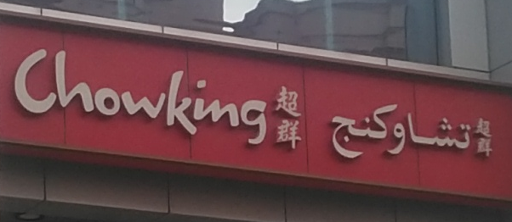
Figure 1. Example of Chinese Language Representation

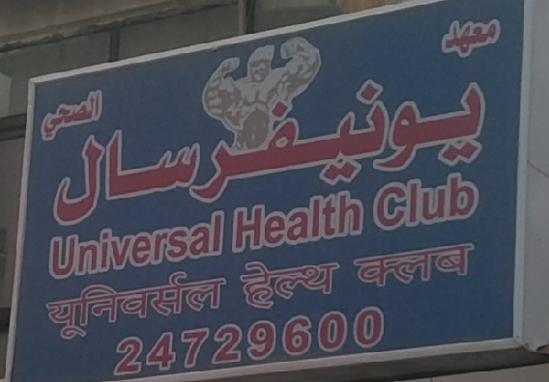
Figure 2. Example of Bengali Language Representation
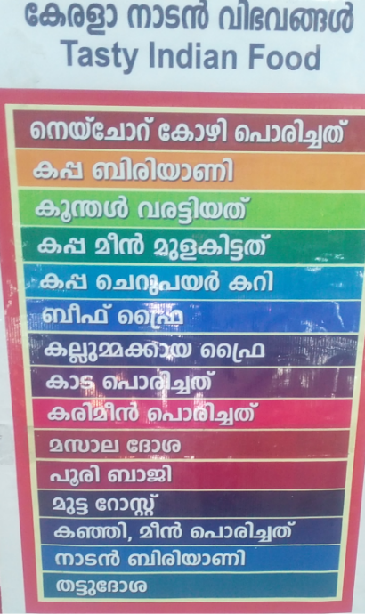
Figure 3. Example of Hindu Language Representation

What is the difference in the representativeness of two contestant languages, namely Arabic and English, on official and non-official signs in the linguistic landscape of Kuwait?

Most official signs are bilingual (n = 31) in English and Arabic, and they represent 73.81% of the overall number of official signs (n = 42) (Figure 4). Out of those 31 bilingual official signs, the Arabic language is represented first and displayed above the English translation on 29 signs (93.55%) (Figure 4), whereas these two languages are placed next to each other, English on the left side and Arabic on the right side, on 2 signs only (6.45%) (Figure 5). However, there are no official bilingual signs on which English is represented first. 11 official signs (26.19%) are monolingual, and out of those 4 official signs represent only English, whereas 7 signs display information only in Arabic.

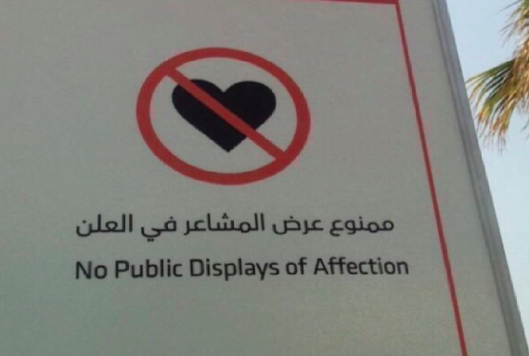
Figure 4. A bilingual official sign
As for non-official signs (n = 108), there are 105 signs which contain only English and/or Arabic and we will elaborate on these further. Namely, out of these 105 non-official signs, 52 signs are monolingual (49.52%), with 35 signs representing only Arabic and 17 signs displaying only the English language. 53 signs (50.48%) are bilingual containing information both in Arabic and English. On 25 bilingual non-official signs information in the Arabic language is represented first, on 11 signs the information in English comes first, whereas on the remaining 17 signs English and Arabic seem to be equally represented as the information in English is displayed on the left side and the information in Arabic on the right side of the sign (Figure 5).
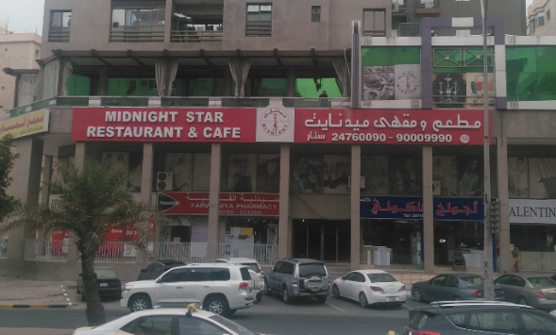
Figure 5. A bilingual non-official sign
These results are rather interesting, as they show that official signs are more frequently bilingual (73.81%) than non-official signs (50%), which points to the consciousness of the governmental institutions of the presence of foreigners in the country and their need to understand the displayed signs. The fact that Arabic is not present on only 4 official signs out of 42 (9.52%) and on only 17 out of 108 non-official signs (15.74%) points to a rather high awareness of nativism. Moreover, it is rather interesting that on bilingual official signs Arabic is displayed first in 93.55% instances which contrasts with the bilingual non-official signs on which Arabic is presented first in 47.17% instances. Such a predominance of Arabic on bilingual official signs can be ascribed to the country’s policies related to the language choice on public governmental signage. On the other hand, on 28 out of 53 bilingual non-official signs (52.83%), English has either an equal representation as Arabic or it is more prominent as it is presented first. Such findings point to the fact that English is directly competing with Arabic on non-official signs. Still, the high representativeness of Arabic and the place given to it on both official and non-official signs seem to suggest that nativism is still valued in Kuwait and that that country still has high ethnolinguistic vitality (EV) if Landry and Bourhis’s (1997) explanations of EV are taken into consideration.

Official signs constitute a vital aspect in an ever-growing expatriate community of the State of Kuwait. One of the critical requirements for a functional community of expatriates is a proper and complete translation of public government signs which convey crucial information regarding street names, warning notices, or names of government buildings. Table 3 examines the translation of English on public signage and strives to see whether the information in Arabic is fully or partially translated into English. All 31 bilingual official signs have been translated from Arabic into English in their entirety. Conversely, the results are somewhat different concerning the translation of bilingual non-official signs into English. Thus, out of 53 bilingual non-official signs, 36 signs have been fully translated, and 17 signs have received a partial translation.

Table 3. Translation on bilingual official and non-official signs
Type of translation | Full translation | Partial translation
Official signs | 31 | 0
Non-official signs | 36 | 17

What is the difference in the representativeness of two contestant languages, namely Arabic and English, on signs displayed in city streets and in side streets in the linguistic landscape of Kuwait?

The research sample was further subdivided into two additional categories, namely the signs found in the city center along the main street and the signs located in side streets outside the city center. Following this division, 106 photos (70.67%) of signs were taken in the city center, whereas 44 photos (29.33%) of signs were taken in side streets. Out of 106 signs displayed in the city center, 36 signs are monolingual (33.96%), 69 bilingual (65.09%) and 1 sign is trilingual (.94%). On the other hand, out of the 44 signs on display in side streets, 27 signs were monolingual (61.36%), 16 signs were bilingual (36.36%) and 1 sign was trilingual (2.27%) (Table 4).

Table 5. Signage in the city center and in side streets
 | Total | Monolingual | Bilingual | Trilingual
Signs displayed in the city center | 106 | 36 | 69 | 1
Signs displayed in side streets | 44 | 27 | 16 | 1
Total | 150 | 63 | 85 | 3

The results also point to an almost equal presence of English (n = 87; 82.07%) and Arabic (n = 88; 83.02%) on the public signage in the city center and to a much greater prominence of Arabic (n = 40; 90.9%) than English (n = 21; 47.73%) in side streets (Table 5), which is an indication of a great presence of the Arab communities in those areas.

Table 5. The representation of English and Arabic on the signage in the city center and side streets

Language | City Center | Side Streets
English | 87 | 21
Arabic | 88 | 40

Out of 68 bilingual signs displaying English and Arabic in the city center, it is rather peculiar to notice that on 42 signs Arabic is displayed first, on 16 signs both languages are represented equally and there are even 10 non-official signs in the city center which are only represented in the English language. Moreover, out of 16 bilingual signs displayed in side streets, 12 signs present information in the Arabic language first, 1 sign presents information in English first and on 3 signs both English and Arabic are given equal credit. It is rather interesting to notice that monolingual signs are more frequently displayed in side streets than in the city center as they represent 33.96% of all the signs displayed in the city center and 61.36% of all the signs displayed in side streets. Out of 36 monolingual signs displayed in the city center, 17 signs are English and 19 Arabic. The discrepancy between monolingual English and Arabic signs is much more conspicuous in side streets, where out of 27 signs there were only 4 monolingual English signs and 23 monolingual Arabic signs.

Table 6. Monolingual Signs in English and Arabic
Monolingual Signs
Area of Inquiry | City Center | Side Streets
English | 17 | 4
Arabic | 19 | 23

Such findings show that monolingual English signs are not highly valued and present in side streets (only in 14.81% cases), where the majority of signs were monolingual Arabic signs. On the other hand, in the city center monolingual English and Arabic signs were almost equally represented, which also indicates that English and Arabic in this sociolinguistic context are two contestant languages. Due to the fact that side streets are not frequently visited by foreigners, Arabic seems to be a predominant language in such places, whereas in the city center, which is visited by many foreigners, both English and Arabic are displayed almost to an equal extent. This shows that in the linguistic landscape of Kuwait English is not competing with other foreign languages but its contestant language is the country’s native language, which proves that immense importance is attached to English in this rather peculiar sociolinguistic context.

- Conclusion

This study aimed to analyze the linguistic landscape of the Governorate of Farwaniya, the biggest governorate in Kuwait. Within the corpus of 150 photographs taken in the city center along the main street and side streets, the overall presence and language structure of official or public signs and non-official or private signs was explored. The results indicated that English is the most dominant foreign language and that no other foreign language is so highly represented in this socio-cultural context with Bengali, Hindi and Chinese each occurring only once in the corpus. Thus, English is the only foreign language competing with the native tongue, namely Arabic in this linguistic landscape. The findings further pointed to a difference between official and non-official signs, as well as between the signs displayed in the city center and those displayed in side streets in terms of the property of monolingualism and bilingualism and the positioning of the languages represented. Thus, it was noticed that on bilingual official governmental signs Arabic is either represented first or Arabic and English are on an equal footing while there were no signs on which English was positioned first. However, this was not the case with non-official signs. Moreover, the findings also pointed to a much lower presence of English monolingual signs in side streets (n = 4) than in the city center (n = 17). Compared to the number of 23 Arabic monolingual signs in side street, it strengthens the belief that nativism is still nourished in this country in particular outside a strictly public domain. The results of the current study are rather important as they provide a clearer insight into the linguistic landscape of yet another country where English has a prominent international role.

References

Backhaus, P. (2005). Signs of multilingualism in Tokyo – a linguistic landscape approach. Unpublished doctoral thesis. Duisberg-Essen: University of Duisberg-Essen.
Backhaus, P. (2006). Multilingualism in Tokyo: A Look into the Linguistic Landscape International Journal of Multilingualism, 3(1), 52-66 doi:10.1080/14790710608668385
Backhaus, P. (2007) Linguistic Landscapes: A Comparative Study of Urban Multilingualism in Tokyo. Clevedon: Multilingual Matters.
Ben-Rafael, E., Shohamy, E., Amara, M. H., & Trumper-Hecht, N. (2006). Linguistic Landscape as Symbolic Construction of the Public Space: The Case of Israel. International Journal of Multilingualism, 3(1), 7-30. doi: 10.1080/14790710608668383
Ben-Rafael, E., Shohamy, E. & Barni, M. 2010. Introduction: an approach to an ‘ordered disorder’. In E. Shohamy, E. Ben-Rafael & M. Barni (eds). Linguistic Landscape in the City. Bristol: Multilingual Matters, xi-xxviii.
Blackwood, R. and Tufi, S. (2015) The Linguistic Landscape of the Mediterranean: French and Italian Coastal Cities. Basingstoke: Palgrave Macmillan.
Bourhis, R. Y. (1992). La lague d'affichage publique et commerciale au Qudbec: Plan de recherche pour l'elaboration dcune loi linguistique. Quebec: Conseil de la langue frangaise.
Bruyèl-Olmedo, A. and Juan-Garau, M. (2009) English as a lingua franca in the linguistic landscape of the multilingual resort of S’Arenal in Mallorca. International Journal of Multilingualism 6(4), 386–411.

Cenoz, J. and Gorter, D. (2003) The linguistic landscape of Erregezainen / Escolta Real. Paper
presented at the Third Conference on Third Language Acquisition and Trilingualism, September 2003, Tralee, Ireland.
Cenoz, J. and Gorter, D. (2006) Linguistic landscape and minority languages. In D. Gorter (ed) Linguistic landscape: A new approach to multilingualism (pp. 67-80). Clevedon:
Multilingual Matters.Chandler, D. (2002). Semiotics: the Basics. New York: Routledge.
Dagenais, D., Moore, D., Sabatier, C., Lamarre, P., & Armand, F. (2009). Linguistic landscape and language awareness. In E. Shohamy & D. Gorter (Eds.), Linguistic landscape: Expanding the scenery (pp. 253–269). New York: Routledge.
Gorter, D. (2006) Further possibilities for linguistic landscape research. In D. Gorter (ed) Linguistic Landscape: A New Approach to Multilingualism (pp. 81–89).
Huebner, T. (2006). Bangkok’s linguistic landscapes: environmental print, codemixing and language change. In D. Gorter (ed.). Linguistic Landscape: A New Approach to Multilingualism. Clevedon: Multilingual Matters, 31-51.
Huebner, T. (2009). A framework for the linguistic analysis of linguistic landscapes. In E. Shohamy, & D. Gorter (Eds.), Linguistic landscape: Expanding the scenery (pp. 88-104). New York: Routledge.

Jaworski, A. & Thurlow, C. (eds). 2010. Semiotic Landscapes: Language, Image, Space. London/New York: Continuum.
"Kuwait". The World Factbook. Central Intelligence Agency. 10 April 2015. Archived from the original on 2 July 2014.
Lamarre, P. (2014). Bilingual winks and bilingual wordplay in Montreal’s linguistic landscape. International Journal of the Sociology of Language(228), 131-151. doi:10.1515/ijsl-2014-0008
Landry, R., & Bourhis, R. Y. (1997). Linguistic Landscaping and Ethnolinguistic Vitality: Empirical Research. Journal of Languages and Social Psychology, Vol. 16 No. 1 , 23-49.

Leclerc, J. (1989). La guerre des langues dans l'affichage. Montreal: VLB Editeur.
Monnier, D. (1989). Langue d’accueil et langue de service dans les commercesa Montréal
[Welcoming language and language of service at merchant locations in Montreal]. Québec, Canada: Conseil de la langue française.

Muth, S. (2008). Multiethnic but multilingual as well? The Linguistic Landscapes of Vilnius
Scollon, R., & Scollon, S. W. (2003). Discourses in Place: Language in the Material World. London: Routledge.
Shohamy, E. and Gorter, D. (2009) Introduction. In E. Shohamy and D. Gorter (eds) Linguistic Landscape: Expanding the Scenery (pp. 1–10). New York: Routledge
Spolsky, B. & Cooper, R.L. (1991). The Languages of Jerusalem. Oxford: Clarendon Press.
Trumper-Hecht, N. (2009) Constructing national identity in mixed cities in Israel: Arabic on signs in the public space of upper Nazareth. In E. Shohamy and D. Gorter (eds) Linguistic Landscape: Expanding the Scenery (pp. 238–252). London: Routledge

Tulp, S. M. (1978) Reklame en tweetaligheid: Een onderzoek naar de geographische verspreiding van franstalige en nederlandstalige affiches in Brussel. [Commercials and bilingualism: A study into the geographic distribution of French and Dutch advertisements in Brussels]. Taal en Sociale Integratie 1, 261-288.

