Implementation of Transportation Problem by Using the Method of Meta-Heuristics Approach

**Muzafer Saračević**

*Novi Pazar University, Novi Pazar, Srbija*

[*muzafers@uninp.edu.rs*](mailto:muzafers@uninp.edu.rs)

**Šemsudin Plojović**

*Novi Pazar University, Novi Pazar, Srbija*

*s.plojovic*[*@uninp.edu.rs*](mailto:muzafers@uninp.edu.rs) *,* [*e.ujkanovic@uninp.edu.rs*](mailto:e.ujkanovic@uninp.edu.rs)

**Enis Ujkanović**

*Novi Pazar University, Novi Pazar, Srbija*

**Senad Bušatlić**

*International University of Sarajevo, Sarajevo, Bosnia and Herzegovina*

[*s.busatlic@ius.edu.ba*](mailto:s.busatlic@ius.edu.ba)

**Abstract**

In this paper authors will present analysis and implementation of possible solutions of vehicle routing problem that is based on simulated annealing method, which belongs to the category of meta-heuristic problem solving approaches. The described problem is rather complex linear programming problem from the field of operation research. Testing of developed applications in software package MATHEMATICA will be described. This application provides great possibilities when it comes to working with numerical algorithms, as well as in the field of symbolic and algebraic calculations.

**Keywords:** Transportation problem, linear optimization, Vehicle routing problem, met heuristics solving approach, simulated annealing

**Introduction**

In business economy mostly used methods are linear optimization methods that allow finding the most appropriate (optimal) solution to the problem in which both the objective of a function (profit) and spending resources are linearly proportional to the values ​​of independent variables. Transportation problem is one of the problems in the field of operations research. The task is to provide an array of buyers and suppliers of a commodity organize transport so that prices are optimal. One of the transportation problems which belong to a linear programming problem is the problem of determining the best times and the vehicle routing problem VRP (Vehicle Routing Problem). In the occasion that there is only one vehicle, and if there are no additional restrictions then the VRP becomes a well-known traveling salesman problem TSP (Traveling Salesman Problem) in that case you need a vehicle to reach every point of the graph with the minimum cost (time).

To define the VRP for distribution or collection of goods, it is necessary to provide basic constraints of the problem. At a given time, a set of vehicles serves set of users. Solving the problem is presented as a set of routes (roads). Each route has a starting point and an ending point in warehouse of all vehicles that use the route. There is a warehouses and the distance between consumers. All user requirements must be met, and all the restrictions imposed respected. The aim is that the total transportation cost is minimized. It is possible to impose different constraints and objectives that may affect the construction of routes during the optimization process. Information needed for a good description of the user in solving VRP is:

1. a starting point that represents warehouse,
2. quantity of goods that need to be collected or delivered,
3. period (time frame) in which it is necessary to serve the user,
4. time required to complete delivery or collection of goods at users,
5. time of unloading or loading, which depends on the type of vehicle and applied technology,
6. subset of the available vehicles that could be used by individual users depending on possibility to access for loading and unloading.

The objective in solving the problem is to find the shortest route that starts at a given node, going through all the other nodes in the starting and ending node. Variables to be optimized must not be only distances. It may be travel costs, travel time or other variables. Determining the best routes, that will be used by group of vehicles serving set of customers will represent a general vehicle routing problem. For the concrete implementation of this problem a software *Mathematica* has been applied, which has many applications in the field of symbolic and algebraic calculations. *Mathematica* includes a great collection of numerical algorithms, as well as a big number of constants and function approximation.

**Approaches for Routing Problem Solving**

The first approach to solving problems is search for exact solutions of the problem. The practical application of this approach is very limited because the optimal solution can be found only in a small number of users. The number of possible routes for the general case of routing vehicles is growing quickly, so it is not possible to expect that this approach in the general case generates usable solutions in real-time that are required in practice.

Heuristic approach represents a use of experience, intuition and your own estimation when solving a problem. Unlike exact methods, heuristic methods do not represent knowledge about the structure and relationships within the model to solve the problem.

Some methods of heuristic approaches to solving the problem of routing vehicles are: *methods of inserting the nearest neighbors, adding the farthest and nearest neighbor added two-pass sweep method, the Clark-Wright method, etc.*  
Heuristic methods represent rule of choice; filtering and rejecting solutions, and also help to reduce the number of possible ways in solving problems. Heuristic algorithms are often based on the construction of routes where the construction and improvement of routes with respect to the target function performed iteratively.

Picture 1. Existing VRP algorithms

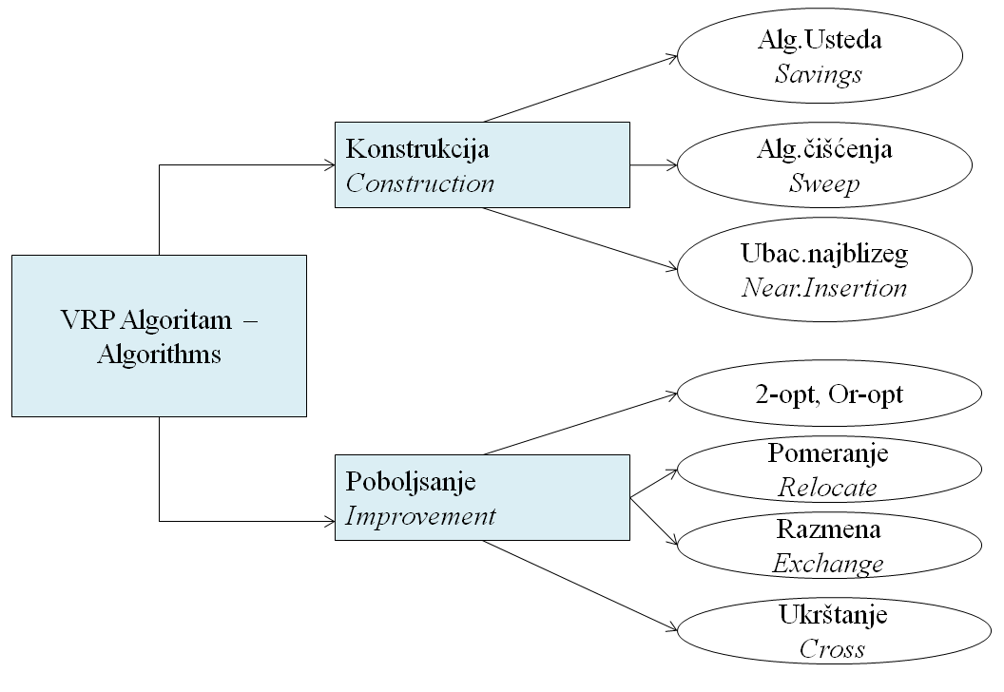

Metaheuristics in practice is a set of algorithms that are used in solving a variety of optimization problems where the algorithm itself is very little changed depending on the problem being solved. Metaheuristics approach of solving the problem of routing of vehicles is often based on local search guided processes that are taken from nature, such as *simulated annealing, genetic algorithms and ant colony*.

Picture 2. The main approaches to solving problems

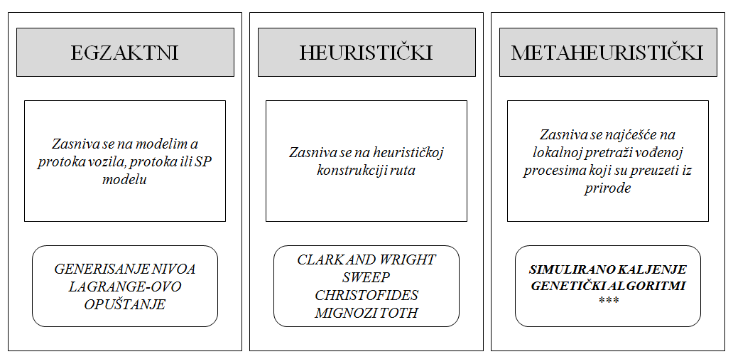

In solving problems by Metaheuristics approach following methods are used:

• Iterative local search (ILS)  
• simulated annealing (SA)  
• deterministic hardening (YES )  
• tabu search (TS)  
• Genetic Algorithms (GA)  
• ant colonies (AC) and  
• Neural Networks (NN).

Picture 3. Classification of VRP heuristics for solving problems

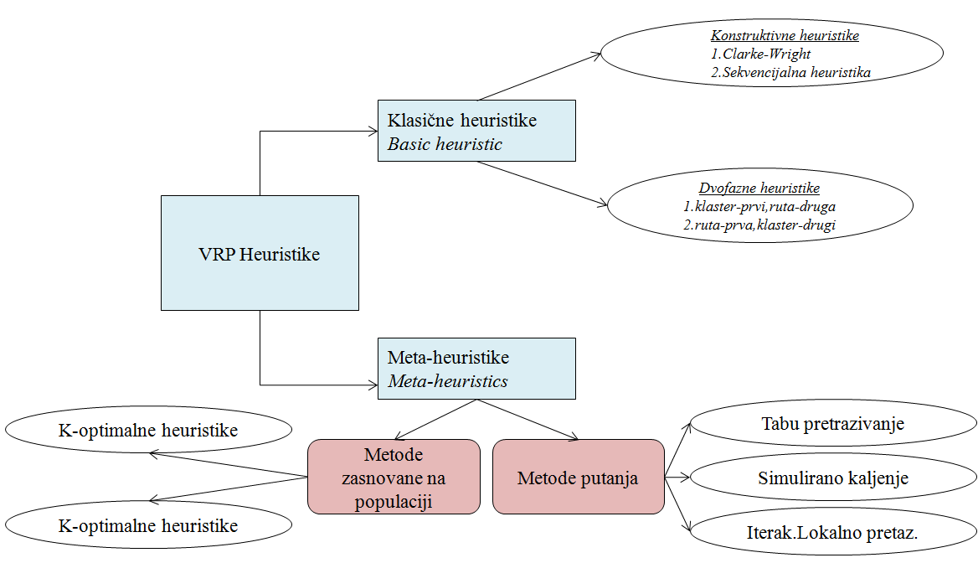

**Metaheuristic Approach and Simulated Annealing**

Classical optimization procedure starts from an initial solution, until the current solution replaces the better from the immediate surroundings and always finds the closest *local optimum*.  
Method of simulated annealing is in the field of stochastic optimization algorithms. With this method we start with one initial solution, replacing the existing solution better, but it can be replaced also by the worse, with a certain probability of acceptance. Probability of accepting worse solutions decreases as the algorithm progresses. Unlike classical optimization procedure with the simulated annealing method *global optimum* is achieved.  
Implemented algorithm, used in this method, contains one parameter; *the temperature*, and the function that determines the global optimum can be seen as: *energy grid* (if we determine minimum) or *negative energy of a grid*, if we determine the maximum. The algorithm starts by choosing the initial solution, and the initial temperature has a relatively large value (1 step). Determining the initial c:

* determine the initial acceptance probability (> 50%) - p0
* determine the average increase of functions for several neighboring solutions - ΔC +
* c0 is calculated as: c0 = ΔC +/ln(1/ p0)

The current solution is replaced by a better one, but it can be replaced with worse with a certain probability of acceptance (step 2). This probability is determined by selecting a random number from the interval [0,1], and the condition that a is less than:

*exp(E(old) – E(new)/T,*

where *E (x)* is a function for which it seeks a global minimum, and *T* is the temperature.

If the expression is true the new solution is accepted. The probability that worse solution has been chosen is greater when the higher temperature. This means that in the beginning of the search space for obtaining solutions is big, and it will be smaller with temperature drop, and by the end of the process is narrowly localized. The behavior of the function is specified with its initial value of the temperature and speed of its drop.

**Algoritham:** *Metaheuristics – Simulated annealing*

***Step 1. - initial solution, and objective function***

*i:=i0; c:=c0;*

*Ci:=C(i);*

*Repetition*

***Step 2 - acceptance of the neighboring solution***

*j:=the neighboring solution(i);*

*Cj:=C(j);*

*△C:=Cj-Ci;*

*accepti:=FALSE;*

***Step 2.1***

*if △C<0 than accept:=TRUE;*

***Step 2.2***

*if exp(-△C/c)>random[0,1] than accept:=TRUE;*

*if accept=TRUE then*

*i:=j; Ci:=Cj;*

*till thermal equilibrium*

***Step 2.3.***

*Decrease parameter c;*

*Till freezing*

*end.*

The final value of *cF* usually will not be presented, but the process is repeated a number of times. Cooling function is usually implemented by multiplying *c* with a number less than 1, while the number of repetitions of the inner loop (*thermal equilibrium*) is usually specified as a numerical value depending on the size (*complexity*) of the problem.

***Testing of software design***

The application that was implemented in software package Mathematica can be downloaded from the link: [*http://muzafers.uninp.edu.rs/*](http://muzafers.uninp.edu.rs/)

**Example 1.** Test example developed applications for the simpler problem, namely the traveling salesman problem (TSP), using the described metaheuristics (simulated annealing).

Procedure TSP(N,S,p0,α,KTL);

Input parameters:

* *N* – number of cities (100)
* *S* – number of repetition at external loop (10-100)
* *p0* – initial probability of accepting bad solutions (0.7-0.8)
* *α* – reduction factor of 'temperature' (0.5-0.99)
* *KTL* – coefficient of thermal equilibrium (repeating cycles*, range 0.1-0.5*)

Picture 4. Testing the TSP problems with parameters [12,0.04,900,82]

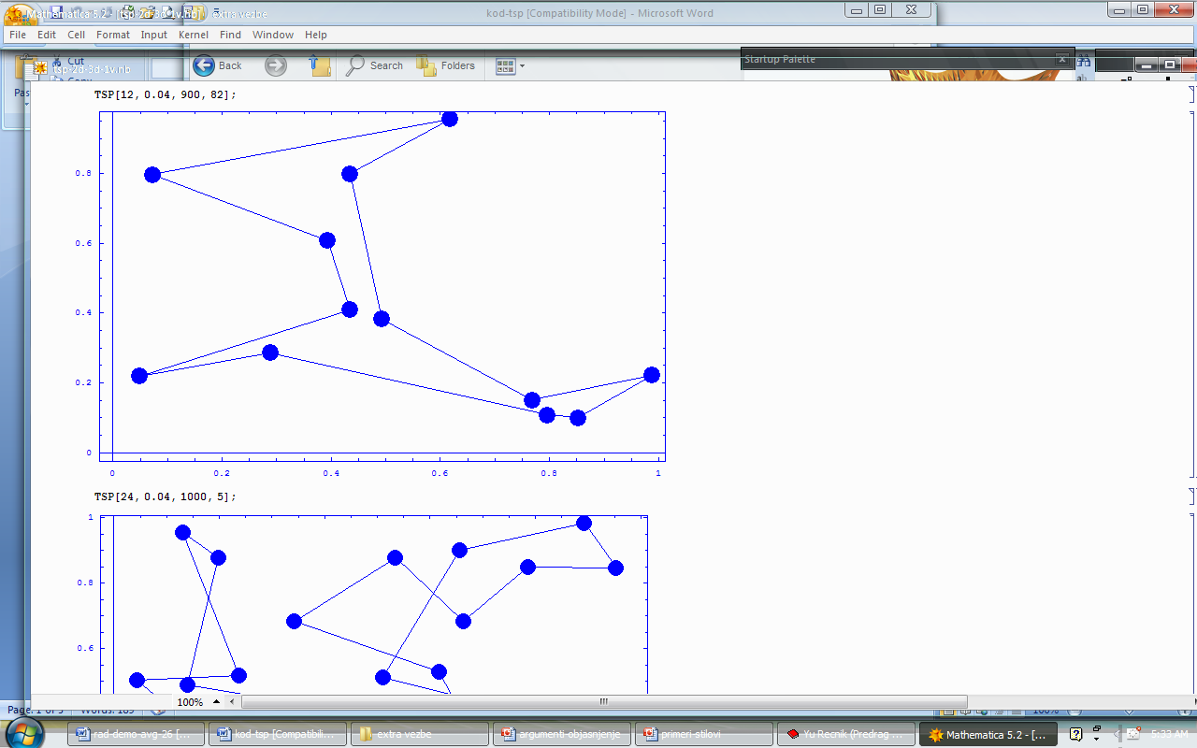

**Example 2.** Test example developed applications for complex problem (VRP - vehicle routing problem), using the described metaheuristics (simulated annealing).

Numberofusers =8;

Coordinates={{145,215},{151,264},{159,261},{130,254},{128,252},{163,247},{146,246},{161,242}};

demand={0,10,7,8,14,20,40,8};

**Capacityofvehicles=150;**

P=VRP[Coordinates,demand,Capacityofvehicles]

TestVRP[Coordinates,demand,Capacityofvehicles,P]

**Example 3.** It is possible to introduce a capacity constraints. In this example it will decrease the capacity (eg. Capacityofvehicles = 60). One type of restriction benefits is the requirement that one user is used in a route that contains a subset of other users, and to serve the customer before (or after) a subset of users.  
Limitation of this type is the problem of collecting and shipping, where the goods that are collected at a single user must provide the same vehicle to another user. A common requirement is one where the route serves several groups of users, and it is known that a group of users to be served.

Picture 5.Testing VRP problem with parameters,  
for example 2 (left) and for example 3 (right)



**Conclusion**

Presented metaheuristics can be considered as an effective natural supplement to mathematical analysis. The above method may be useful when the system (business) or process is relatively complex (for example, when we do not dispose analytical methods for solution of a mathematical model). Also, the method can be useful when it is not possible to analyze in detail the system in a real environment.

The above presented implementation of simulated annealing provides many benefits to the given procedures of experimentation:

1. to a large extent, can reduce the risk, depending on the reality that is observed (eg, economic risk, the risk of attack and defense),
2. time saving,
3. obtaining a clearer picture of the processes, structure and function of the system to be analyzed,
4. correct analyses of complex industrial and other systems.

**References**

C. Nilsson (2003). Heuristics for the traveling salesman problem. Tech. Report, Linköping University, Sweden.

C. White, G. Yen (2004). A Hybrid Evolutionary Algorithm for Traveling Salesman Problem, Evolutionary Computation, 2004. CEC2004. Congress on, Vol.2, pp. 1473 – 1478.

D. Johnson, L. McGeoch (1995). The traveling salesman problem: a case study in local optimization.

I.Salajic, J.Nikolic, M. Žoljom (2001). TSP – Problem trgovackog punika na potpunom grafu, primjenom genetskog algoritma (GA) i algoritma simuliranog kaljenja (SA).

J. Kratica (2000). Paralelizacija genetskih algoritama za rešavanje nekih NP - kompletnih problema, Doktorska disertacija, Beograd.

J. Little, K. Murty, D. Sweeney, C. Karel (1963). An algorithm for the traveling salesman problem. Operations research, 11 (6), pp. 972-989.

K. Binder, ed. (1986). "Monte Carlo Methods in Statistical Physics", second ed., Springer-Verlag.

M. Garey, D. Johnson (1979). “Computers and Intractability: A Guide to the Theory of NP-Completeness”. W.H. Freeman.

M. Pilat, T. White (2002). Using genetic algorithms to optimize ACS-TSP, Lecture Notes in Computer Science, v. 2463, pp. 282-287.

P. Borovska (2006). Solving the Travelling Salesman Problem in Parallel by Genetic Algorithm on Multicomputer Cluster, International Conference on Computer Systems.

R.Thamilselvan, P. Balasubramanie (2009). A Genetic Algorithm with a Tabu Search for Travelling Salesman Problem. Int. Journal of R.T. in Engineering, Vol. 1, pp. 607-610.

Richard J. Gaylord, Samuel N. Kamin and Paul Wellin, (1993). "Introduction to Programming with Mathematica", TELOS/Springer-Verlag Publishers.

S. Eberle (2008). A Polynomial Algorithm for a NP-hard to Solve Optimization Problem, Dissertation der Fakultät für Physik der Ludwig-Maximilians-Universität München.

S. Kirkpatrick, C. D. Gellat and M. P. Vecchi, (1983). "Optimization by simulated annealing", Science 220, 671.

S. Lin, B. Kernighan (1973). An effective heuristic algorithm for the traveling-salesman problem. Operations research, 21(2), pp. 498-516.

Saračević M., Mašović S., Međedović E. (2010). Application of object-oriented analysis and design in navigation systems and transport networks, 10th International Conference "Research and Development in Mechanical Industry", RaDMI 2010, ISBN: 978-86-6075-017-6, pp. 656-664.

Saračević M., Mašović S., Plojović Š. (2012). UML modeling for traveling salesman problem based on genetic algorithms, Souteast European Journal of Soft Computing, ISSN: 2223 -1859, Vol.1, No 2, pp.72-79, elected to IUSSCRG 2012.

T. Cormen, C. Leiserson, R. Rivest, C. Stein, (2001)."Introduction to Algorithms", MIT Press and McGraw-Hill, second edition,.