War in Afghanistan:
A Look Back at Twenty Years of American Presence

Authors: Mustafa Baĝ, Selma Delalić, Nataša Tandir, Adem Olovčić

Abstract:

The history of Afghanistan is abundant in crises, coups, assassinations, political intrigues, as well as invasions and conquests. The last 40 years have been marked by long crises and conflicts: Soviet invasion 1979-1989, the civil war 1989-2001, the American invasion 2001-2021 with disastrous consequences for the country and the people. The invasion carried out in the name of ‘war on terrorism’, ‘bringing democracy’ and ‘freedom’, as a matter of fact, led to instability, turmoil, sectarian wars, deaths of tens of thousands of civilians and the formation of new terrorist organizations in the country, rather than peace and stability. War has become commonplace in Afghanistan. Once seen as the ‘shining star’ of Central Asia, Afghanistan is now known as the country exporting terrorism, drugs and refugees. The paper aims at showing causes and consequences of two decades long American presence in Afghanistan that left lasting imprint on Afghan society.

Key words: Afghanistan, United States, invasion, Taliban, human rights violation.

Introduction

The history of Afghanistan dates back almost 3,000 years BC, although the oldest historical documents mentioning Afghanistan date back to the 5th century BC. Located at the crossroads of strategic routes connecting Asia and Europe, Afghanistan has been the target of great world empires for centuries: the Persian, Maujyan Empire of India, Kushan, the Arab dynasties of Abbasids, Samanids, Ghaznavids, and Mongols. The founder of modern Afghanistan and the Afghan nation is considered to be Ahmad Shah Durrani (1723-1773), who managed to unite numerous Pashtun tribes and by 1760 build an empire that stretched all the way to India. In a bid to protect its colonial possessions, and to annex Afghanistan, the country has repeatedly come under attack from the British Empire: 1838-42, 1878-80, 1919-21. The signing of the Treaty of Rawalpindi ended the third Afghan-British war from which Afghanistan emerged as an independent state. Precisely, the geographical location of Afghanistan had a decisive influence on internal events, foreign policy positions, but also the overall history and survival of the country. (Isby, 2010)

Afghanistan is located in a unique geopolitical environment, the neighborhood very difficult to manage. It is positioned between the countries of Central Asia, the former Soviet Union to the north, China to the northeast, Iran to the west and Pakistan to the east and south . The population, estimated at between 35 to 40 million, in the absence of a census and reliable statistics, is multi-ethnic, with two dominant ethnic groups, the Pashtuns and the Tajiks, (also Hazaras, Turkic ethnic groups, Uzbek, Turkmen, Kyrgyz, and Kazakhs) and spread out in mountainous regions and plains with successive intermingling to ensure social cohesion and the hold of central power, which has not been completely achieved. Afghanistan's history is full of crises, coups, assassinations, wars, and political intrigues. The history is also marked by various invasions and conquests, passages of Buddhist, Greek and Muslim civilizations. (Khalilzad 1991, 81)

The last 40 years of the history of Afghanistan have been marked by long crises and conflicts: the Soviet invasion 1979-1989, the civil war 1989-2001, the American invasion 2001-2021 with disastrous consequences for the country and the people. As we can see, the country was occupied successively by two superpowers. In the 12-year period from the end of the Soviet occupation to the beginning of the American occupation, (1989-2001) dozens of civil wars took place in Afghanistan. In addition to killings, serious violations of human rights, notably children’s and women’s rights, poor education, destroyed institutions, and the infrastructure being completely collapsed, marked the Afghan society. 9/11 terrorist attacks, apart from changing the course of the world politics, paved the way for the U.S. invasion of Afghanistan on October 7, 2001. (Barfield, 2012) The invasion carried out in the name of ‘war on terrorism’, ‘bringing democracy’ and ‘freedom’, as a matter of fact, led to instability, turmoil, sectarian wars, deaths of tens of thousands of civilians and the formation of new terrorist organizations in the country rather than peace and stability. All this came at the cost of trillions of dollars.

War has become commonplace in Afghanistan. Once seen as the ‘shining star’ of Central Asia, Afghanistan is now known as the country exporting terrorism, drugs and refugees. Many illegal armed groups are active in the country, including the ISIS-Khorasan. Millions of innocent civilians lost their lives or injured, millions of others became refugees. And there are no promising developments for the future. If there is one thing certain, it is that the war is still going on and it is not known how long it will last. (Malkasian, 2021)

The Year 2021 and the Withdrawal of the U.S. Troops

… “My fellow Americans, the war in Afghanistan is now over. I’m the fourth President who has faced the issue of whether and when to end this war. When I was running for President, I made a commitment to the American people that I would end this war. And today, I’ve honored that commitment. It was time to be honest with the American people again. We no longer had a clear purpose in an open-ended mission in Afghanistan. After 20 years of war in Afghanistan, I refused to send another generation of America’s sons and daughters to fight a war that should have ended long ago.”

On August 31, 2021, the U.S. President Joe Biden announced that the withdrawal of U.S. forces from Afghanistan was complete and the mission is over. (Biden, 2021) Actually, President Barack Obama was the first to begin the withdrawal of U.S. troops from Afghanistan. Obama shared the obsession with Biden: to bring the U.S. soldiers back home from Afghanistan before leaving the White House. To that end, the year 2014 was supposed to be the year of military withdrawal from Afghanistan. But the reality on the ground ⎯ the pressure of the Islamic State in Iraq and the all-out push by the Taliban as well as the brutal emergence of the Islamic State Khorasan (ISIS-K) in Afghanistan, forced Obama to postpone military disengagement. (Wilson Center, 2021) The withdrawal from Iraq in 2011 for many turned out to be a strategic mistake, which must not be repeated in Afghanistan. The Pentagon, the Congress, and the majority of foreign policy experts pushed very hard to maintain the military presence. Joe Biden, Obama's vice president at the time, was the most supportive of the administration in withdrawing from Afghanistan and narrowing the mission around counterterrorism. Faced with the threat of the Taliban and the ISIS, Obama had finally postponed the repatriation of the troops. Finally, it was Donald Trump who rang the bell for the American soldiers to come home with the President Biden finalizing the operation.

Biden’s determination to operationalize unconditional withdrawal of the U.S. troops from Afghanistan reflects his willingness to resist pressure from the military and the overwhelming majority of the U.S. expert community to maintain a minimal and indefinite military presence on the ground. The American withdrawal was inevitable and expected both by the Americans and the international community. But it was the way it was done that surprised everyone and shook the confidence of the U.S. allies. Instead of first evacuating civilians, and then military personnel and diplomatic staff, and leaving the military bases, exact opposite happened: the early closure of the Bagram base, the hub of American operations since 2001, deprived the United States of a precious logistical platform for evacuation operations. Washington's decision to rapidly withdraw from Afghanistan, and its failure to take seriously the calls of NATO/European allies for more planned withdrawal, caused discomfort among them. Biden's stated commitment to multilateralism and consultation with allies in fact disguised a structural tendency of successive U.S. administrations to bypass U.S. allies when it comes to making highly strategic decisions. In the opinion of many Europeans ‘NATO is seen as a tool to serve U.S. global interests.’ (Katz, 2021)

As the departure of American and NATO troops ended, let us remind of the major dates of the Afghanistan war starting from 9/11 terrorist attack to the present day:

- On September 11, 2001, two days after the suicide bombing that killed Ahmed Shah Masud in Afghanistan, commander of the Northern Alliance and a key figure in the fight against the Taliban, 19 terrorists affiliated with the Al Qaeda hijacked four airliners, two of which crashed into the twin towers of the World Trade Center in New York, another into the Pentagon in Washington, D.C., and the fourth into a field in Shanksville, Pennsylvania. These attacks were witnessed live by the entire world, killing 2,977 people and injuring more than 6,200.
- In the afternoon of September 11, 2001, Donald Rumsfeld, President George W. Bush's Secretary of Defense, identified Al Qaeda and its leader, Osama Bin Laden, as responsible for the attacks, but he also sought to incriminate Saddam Hussein's Iraq. That evening, from the Oval Office in the White House, President Bush launched what he called the “war on terror”.
- A week later, the U.S. Congress passed the Authorization for the Use of Military Force, a law still in force that defined the American response against Al Qaeda.
- On September 20, 2001, during the Congress session, George Bush issued an ultimatum to the Taliban holding power in Afghanistan to "hand over all the Al Qaeda leaders hiding in their territory or share their fate". The United States offered $25 million reward for information leading to the arrest of Osama bin Laden, the leader of Al Qaeda.
- Fifteen days later, on October 7, 2001, Operation Enduring Freedom began with a bombing campaign against Al Qaeda and the Taliban. On the ground, American and British Special Forces, supported by the Northern Alliance, removed the Taliban from power.
- Kabul fell in the mid-November 2001, followed by the Taliban stronghold of Kandahar. Their leader, Mullah Omar, fled, as did Osama Bin Laden. The Americans tracked him unsuccessfully in the snowy mountains of Tora Bora, along the Pakistan-Afghanistan border.
- In December 2001, the United Nations signed the Bonn Agreement, which provided for a gradual restoration of ‘democracy’ in Afghanistan with the creation of an interim Afghan government led by Hamid Karzai.
- International Security Assistance Force (ISAF), a military coalition under the aegis of NATO, was mandated by the United Nations to operate on the ground alongside 2,500 American soldiers.
- In March 2002, American forces and their allies launched Operation Anaconda to dislodge several hundred Taliban and Al Qaeda fighters: this fighting, the most violent since the beginning of the American campaign, resulted in several hundred Taliban deaths.
- In April 2002, George W. Bush called for a "Marshall Plan" to rebuild Afghanistan.
- In June 2002, Hamid Karzai was elected head of the transitional government pending general elections in Afghanistan.
- In January 2004, the country adopted a new constitution, which included equal rights for men and women.
- In December 2004, Hamid Karzai was elected president to rebuild the country.
- On the ground, Americans and the NATO created Provincial Reconstruction Teams (PRTs), which carried out both security operations and humanitarian missions. By the end of the year, 9,400 American and 4,800 NATO troops were on the ground.
- In March 2003, George W. Bush decided to extend his "global war on terror" to Iraq. Although Saddam Hussein's regime was a fierce opponent of the jihadists, it was designated by Washington as a supporter of international terrorism and a holder of weapons of mass destruction.
- On March 20, 2003, Iraq was invaded and the bulk of the American military effort was concentrated there.
- On May 1, 2003, Defense Secretary Donald Rumsfeld went to Kabul to announce the end of "major combat activities" in Afghanistan, where 8,000 American soldiers were stationed. Instead, the focus shifted to "stabilization and reconstruction operations".
- Thus, Afghanistan was overnight relegated to the background. The Secretary of Defense, like the rest of the American administration, seemed to lose sight of the meaning of the mission in that country.
- In September 2003, he wrote, "I have no visibility into who the bad guys are." (Read, 2019) These notes, published in 2019 by the Washington Examiner in the "Afghanistan Papers," reveal the extent of dysfunction in the course of the American-led war.

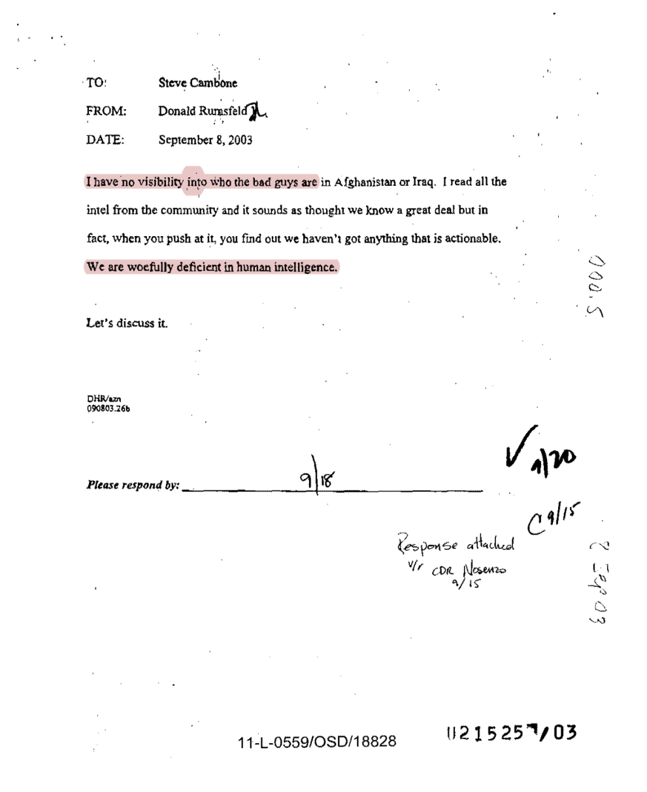

Figure 1: A secret history of the war
(Source: The Afghanistan Papers, 2003 memo: 'I have no visibility into who the bad guys are'
https://www.washingtonpost.com/graphics/2019/investigations/afghanistan-papers/documents-database/?document=snowflake_badguys_cambone_nsarchive_09082003)

- In a video broadcast four days before the 2004 presidential election, Osama Bin Laden demonstrated that he was still alive, despite persistent rumors about his death in the Tora Bora / Jalalabad area.
- From 2004 onwards, the Taliban and Al Qaeda changed their strategy: they preferred suicide attacks to direct confrontations, which had cost them thousands of lives.
- Suicide attacks became their weapon of choice, with the number of attacks increased from six in 2004 to 21 in 2005 and 123 in 2006.
- At the NATO summit in Riga, Latvia, in November 2006, divisions arose among member states over the commitment of their troops in Afghanistan. The NATO Secretary General hoped that the Afghan National Army could begin to regain control of security in 2008. A year later, the U.S. Defense Secretary Robert Gates criticized NATO countries for not sending enough troops.
- Relations with the Afghans also begun to deteriorate: foreign forces were regularly accused of misconduct.
- In the first four months of 2008, about 200 Afghan civilians were killed by international forces, mostly in air attacks; at the same time, 300 civilians were killed in Taliban attacks.
- In December 2009, Barack Obama sent 30,000 additional troops and outlined a timetable for withdrawal: the first American troops could leave the country before the end of his first term.
- In 2010-2011, at the height of their presence, some 100,000 American troops were deployed in Afghanistan.
- At its annual summit, the NATO announced that it would gradually, from 2011 to 2014, transfer responsibility for operations on the ground to Afghan security forces.
- On May 1, 2011, after more than a decade of tracking, Osama bin Laden was killed in Abbottabad, Pakistan, by a U.S. Navy Special Forces commando. Nearly ten years after the attacks of September 11, "justice is done", declared Barack Obama during a televised address.
- Nearly two months after the death of Osama bin Laden the U.S. Secretary of Defense, Robert Gates, confirmed the beginning of discussions with the Taliban.
- In December 2011, the international community met in Bonn to prepare aid framework for Afghanistan after the departure of NATO troops at the end of 2014.
- At the end of 2011, the Taliban announced the opening of an office in Qatar to facilitate peace talks with the United States. But two months later, they suspended it and accused Washington of not having kept its promise to exchange prisoners.
- At the same time, relations between Afghan President Hamid Karzai and the West continued to deteriorate: after the massacre of civilians by a U.S. serviceman and the release of photographs of U.S. soldiers posing next to the corpses and remains of Taliban fighters, the Afghan president asked them to leave their outposts in the villages.
- At the NATO summit in Chicago, the Atlantic Alliance confirmed that it would have no more soldiers in Afghanistan after December 31, 2014, and that by mid-2013 the Afghan army would have taken control of the last areas still under the Western control.
- The United States began negotiating with Kabul government that was supposed to define the terms of the American presence after the end of the NATO forces' mission. In the spring of 2014, Barack Obama further clarified the timetable for the withdrawal: the last American soldiers would leave the country by the end of 2016. The Taliban increased their attacks.
- Following the 2014 Afghan presidential election, the two rival candidates, Ashraf Ghani and Abdullah Abdullah, signed a power-sharing agreement on September 21. The beginning of the joint rule was marked by the fight over the allocation of key ministries, while the Taliban advanced and increased their attacks.
- On December 28, 2014, ISAF, the NATO’s combat force, ended its mission.
- On January 1, 2015, the Resolute Support mission took over to assist and train the Afghan army. (NATO, 2022)
- The announced U.S. withdrawal was constantly postponed. In early 2015, three months after the withdrawal of NATO troops, there were increasing signs of concern about the ability of Afghans to assume responsibility for their own security.
- In March 2015, Washington slowed the withdrawal, to ensure that local forces were better trained and equipped.
- A year later, as his term in office drew to a close, Barack Obama adjusted the withdrawal timetable even further: he announced that the United States would keep 8,400 troops in Afghanistan until 2017.
- During his candidacy, Donald Trump declared, in October 2015, that "the war in Afghanistan was a mistake." But once he became president, he changed his mind and declared, in August 2017, that the U.S. would remain in the country: a rapid withdrawal of the 8,000 soldiers still there would, according to him, create "a vacuum" that would benefit the “terrorists”.
- The beginning of 2018 was marked by an upsurge in attacks. In the first six months, 1,700 civilians were killed, most of them in attacks by the ISIS-K. According to the UN, this was the worst death toll in a decade.
- In 2018, the dialogue with the Taliban was no longer taboo, but the Afghan president kept out of negotiations on the future of his country.
- In November 2019, Donald Trump visited Afghanistan and confirmed that he wanted to reduce the number of American soldiers.
- On February 29, 2020, the United States and the Taliban signed an agreement that called for the withdrawal of U.S. troops in mid-2021.
- Intra-Afghan peace negotiations began on September 12, 2020, in Doha, Qatar, causing concern in liberal circles in Kabul.
- After Joe Biden's April 14, 2021 statement, NATO announced that it would begin withdrawing approximately 10,000 fighters still engaged with the Americans by May 1.
- The Taliban have warned Washington not to miss this date, which was the part of the 2020 U.S.-Taliban agreement.
- The U.S. President Joe Biden stated that the withdrawal was not possible on 1 May and announced that he postponed this date to 31 August. (Bag, 2019 & AP, 2021)

However, before the end of the US withdrawal process, the Taliban reached the gates of Kabul. On August 15, 2021, Afghan President Ashraf Ghani fled the country. The government fell. While the evacuation of American soldiers continued, the Taliban began to consolidate their power across the city. Dramatic images surfaced again. With the entry of the Taliban into the capital Kabul, the U.S. accelerated the evacuation of its soldiers and embassy personnel. Photos showing the transfer of personnel from the embassy to the Kabul Airport by helicopter were widely shared on social media. These images reminded many of another event. In 1975, at the end of the Vietnam War, photographer Hulbert van Es photographed people boarding a helicopter that landed on the roof of a building in Saigon, the capital of South Vietnam during the war. Nearly half a century later this photo become iconic again, only this time in Kabul. (Malkasian, 2021)

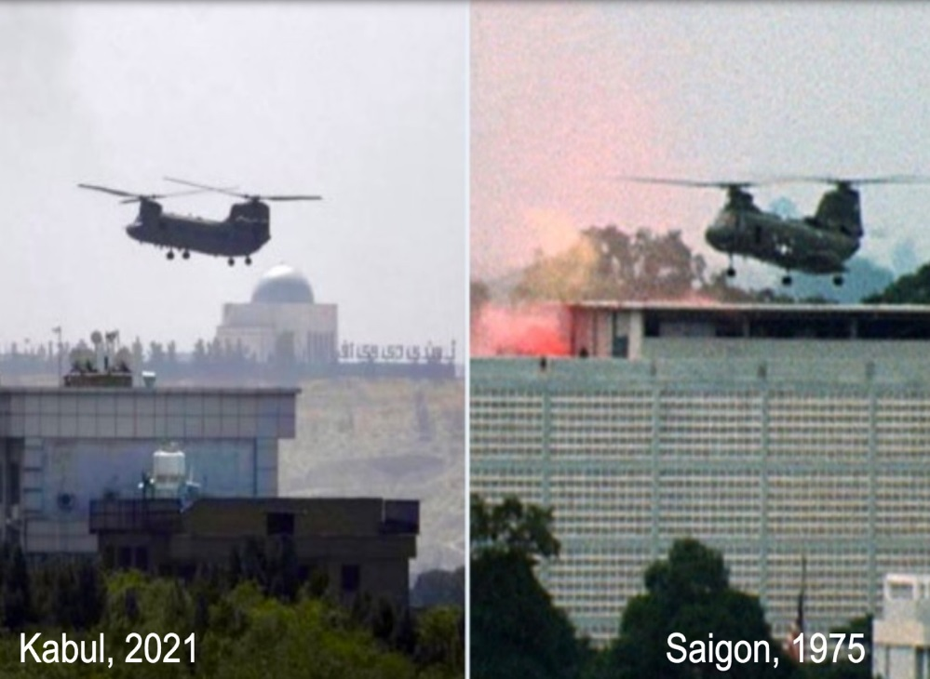

Figure 2: US evacuation in Kabul (left), US evacuation in Saigon (right)
(Source:https://www.opindia.com/2021/08/fall-saigon-vietnam-kabul-afghanistan-america-rescue-chinook/)

Experts and some representatives of both Democratic and Republican Party in the USA, made comparisons between the Taliban's takeover of Kabul and what has been called the "fall of Saigon". Although the Biden Administration said that they did not see Kabul and Saigon as parallel situations, what happened on the ground revealed that both were almost the same. The "fall of Saigon" took place two years after U.S. troops had withdrawn from Vietnam. The “fall of Kabul” happened while the U.S. was already trying to complete the process of leaving Afghanistan.

Afghan elites were vocal in accusing the Americans of abandoning them. Although not knowing the state of mind of the Vietnamese at that time, the abandonment syndrome experienced by the Afghan people today will not be erased from their memories for a long time. An Afghan female Senator, who fled to Europe under very difficult conditions after the arrival of the Taliban, stated that "America handed us over to the mercy of Taliban." Another lawmaker, who fled abroad with his family, claimed that, "Washington and the Taliban made a secret deal… the USA stabbed the Afghan people in the back… they deceived us all". A woman who worked in the presidential palace for a long time and was very close to the top figures said, "Many people in the palace think that former President Ashraf Ghani was also in this 'game'." The female employee did not want to give her name and position, even though she lives now in a Western country. A young lady, who was a manager at an NGO in Kabul, said that Washington has left over a million of Afghan women at the mercy of the Taliban, and that she no longer finds the U.S.’s claims such as democracy and human rights credible. (Gossman et al., 2021)

It should not be forgotten that the U.S. withdrawal, leaving the central government, their 'ally', sent a dramatic message to Washington’s other 'allies' in different parts of the world. For example, the Taiwanese in Asia, the Kurds in the Middle East, or the administrations relying on American aid in the different parts of the world could not resist thinking that ‘Washington might one day abandon them’ as well. Experience at Kabul Airport for many Afghans will remain as a humiliating memory. Painful images of chaotic withdrawals at the airport were the U.S. 'nation-building' promise. Some people lost their lives after clinging to C-17 jets as they took off from Kabul Airport, in an attempt to flee from the Taliban. Michael Herr, in his book “Dispatches” published in 1977, refers to the lost generation, the people who spent their youth in the Vietnam War and can no longer return to their ordinary daily lives: "I think that Vietnam was what we had instead of happy childhoods." The same can be applied to the Afghans.

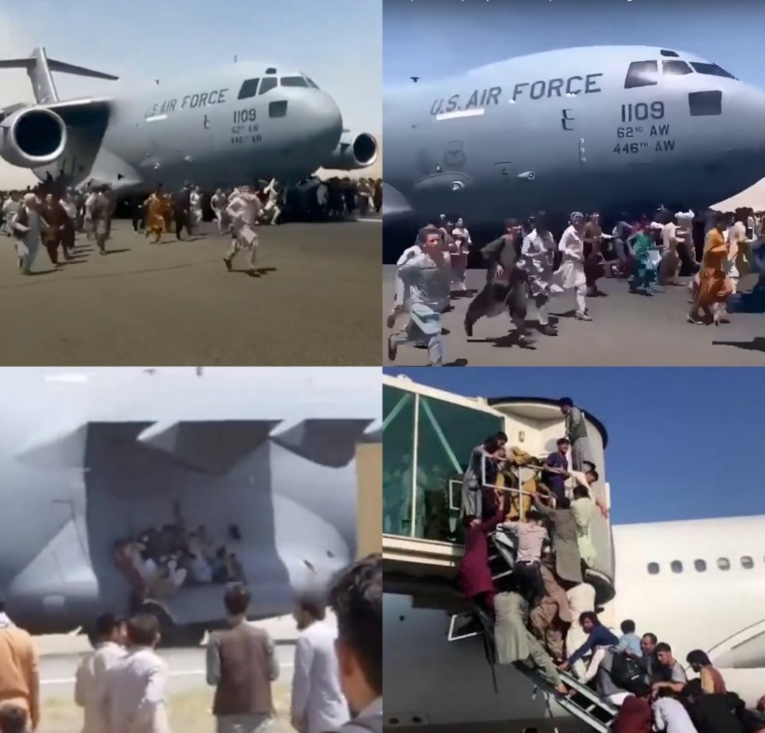

Figure 3: Afghans try to flee the country
(Source: https://www.wsj.com/articles/three-killed-in-kabul-airport-as-afghans-scramble-to-escape-taliban-11629096273)

The Cost of War in Afghanistan

As soon as the American troops withdrew from Afghanistan the Taliban regained control of the country. As already mentioned, the American intervention in Afghanistan, launched on October 7, 2001, a few weeks after the September 11 attacks, was the longest conflict in the history of the United States. In this context, figures on the civilian and military losses during the 20-year war, as well as the financial expenditures of the occupation will be provided in this section. Thereafter, the reasons will be explained as to why the war was not won despite all these expenditures, high technology and military superiority, and why the Taliban took control of the whole country very easily. (Masood, 2020)

The war that lasted for two decades brought many deaths, displacements and economic costs. The bill of the 20-year American occupation has been very costly for both Afghanistan and the rest of the world. In cross-border operations in Afghanistan and (sometimes) in Pakistan, as a direct result of war, approximately 241,000 people were killed since 2001, including more than 71,000 civilians and at least 75,000 have been injured. (Knickmeyer, 2021) Civilian casualties rose sharply after the U.S. military relaxed the rules of engagement for airstrikes in Afghanistan in 2017. During the administration of former U.S. President Donald Trump, the number of civilians killed in the U.S-led airstrikes in Afghanistan increased by 330 percent. Tens of thousands of people were detained as terror suspects in Afghanistan, of whom 50,000 in the first three years of the war. According to research conducted as part of Brown University's "Costs of War" project, many civilians died in Afghanistan due to crossfire, improvised explosive devices, assassinations and bombings. The study shows that the “United States has spent an estimated more than $2 trillion on military operations” during its 20-year presence in the country. (Crawford and Lutz, 2021)

In addition to the cost of the war in Afghanistan, which the USA financed by borrowing, the United States has provided more than $145 billion to implement reconstruction programs in Afghanistan since 2002, and spent $83 billion on training and equipment for Afghan security forces over the past 20 years. Since October 2001, 800,000 U.S. troops have been deployed in Afghanistan. This number exceeded 50,000 in 2009 and reached 100,000 for the first time in 2010. (Knickmeyer, 2021) The then U.S. President, Barack Obama, announced his withdrawal plan in 2011, and in this context, he said that 10,000 troops should be withdrawn by the end of the year, and that it would „continue at a steady pace” until it “handed over security responsibilities to the Afghans” in 2014. (Sopko, 2021) Since then, the number of the U.S. soldiers in Afghanistan fell below 50,000 again in 2013. In 2014, Obama announced his plan to withdraw nearly all U.S. troops from Afghanistan by the end of 2016, when his second term expires. As already mentioned, in 2015, Obama stated that the situation in Afghanistan was too fragile for the U.S. military to abandon. The administration of Donald Trump negotiated a withdrawal agreement with the Taliban in February 2020, setting May 1, 2021 as a definitive date for the final withdrawal. Joe Biden, who took over the presidency in January 2021, postponed this date to August 31.

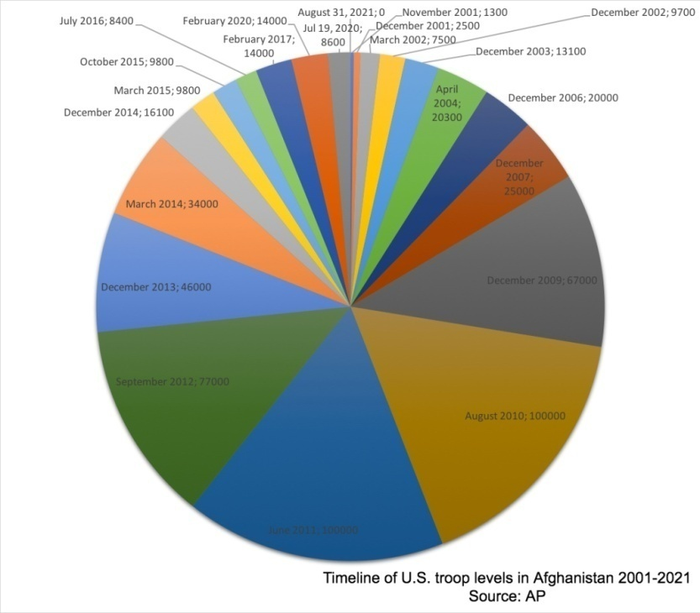

Figure 4: A timeline of the US military presence in Afghanistan
(Source: https://apnews.com/article/fd2ec2085b0b4fd3ae0a3b03c6de9478)

The debacle of the Afghan government and the tragic turmoil that accompanied the final withdrawal of U.S. and allied troops from Kabul, however, was a fitting conclusion to the two-decade cycle of the "war on terror" inaugurated by the George W. Bush administration in the aftermath of the 9/11 attacks. The U.S. intervention and occupation of Afghanistan has just ended with the withdrawal of the last troops from Kabul airport. Since the start of the evacuation process from Afghanistan on August 14, the U.S. administration displaced more than 125,000 people from the country. This will remain the longest war in the history of the United States, a robust and militarized country involved in nearly 100 conflicts since its revolutionary founding in the late 18th century. (Carter, 2021)

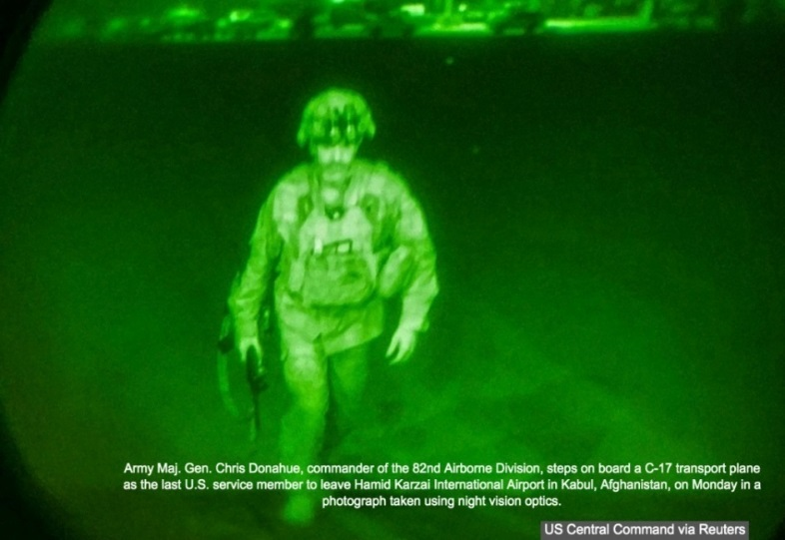

Figure 5: The last US soldier to leave Afghanistan
(Source:https://www.nbcnews.com/news/world/last-soldier-leave-afghanistan-nicknamed-flatliner-was-uniquely-prepared-moment-n1278260)

During the U.S. intervention in Afghanistan 2001-2021, the U.S. was headed by four presidents: George W. Bush, Barrack Obama, Donald Trump and Joe Biden. During the time, 2,461 U.S. soldiers lost their lives, while 20,744 were injured. According to the Washington Post, the developments in the region since 2001 have resulted in the death of 66,000 Afghan national army members and police, 1144 soldiers from NATO and other countries serving in Afghanistan, 51,191 people from other groups, especially the Taliban, and 444 aid workers. It cost the lives of more than 70 journalists. The number of countries that took part in the Afghanistan war, including NATO and partner countries, was 51. (Knickmeyer, 2021)

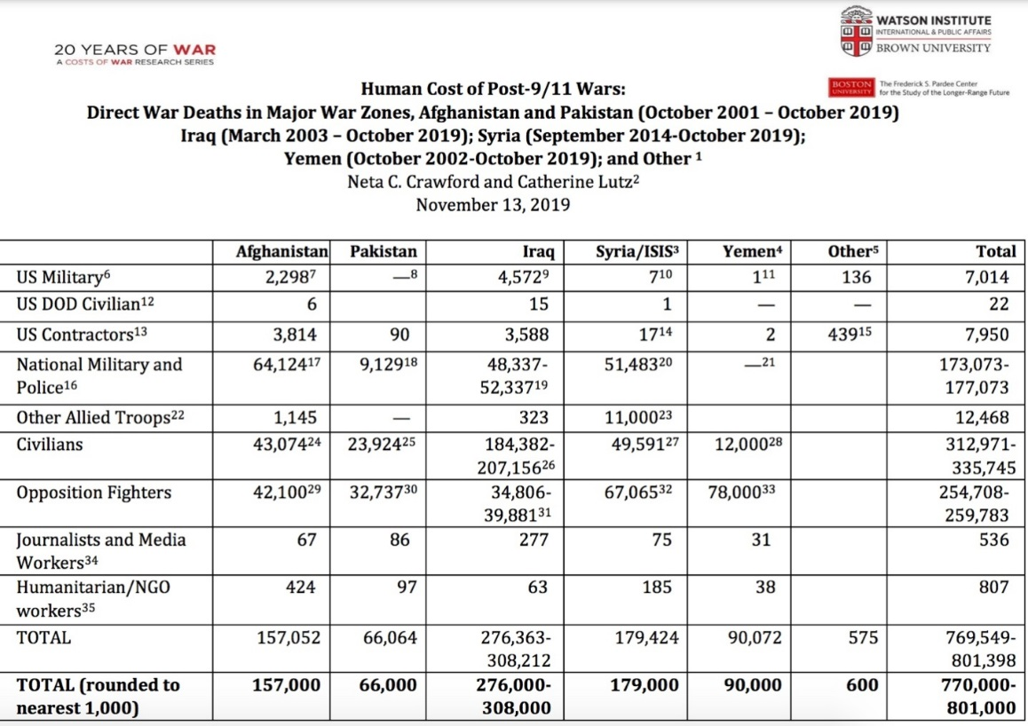
Figure 6: Human Cost of Post-9/11 Wars
(Source: https://watson.brown.edu/costsofwar/figures/2021/WarDeathToll)

The Causes and the Consequences of US’s Strategic Failure in Afghanistan

Despite spending trillions of dollars and the loss of thousands of service members over the course of 20 years, has the end goal been achieved in Afghanistan? The answer would be 'no' by almost everyone, including Americans. Namely, not only the U.S. Intelligence Community, but the entire U.S. strategy and all the institutional structures that worked in Afghanistan within the scope of this strategy experienced a great failure. The entire American intervention was a failure, and these are some of the reasons:

Home raids
In 2001, when the coalition arrived in Afghanistan, the Afghans were happy to see them arrive. The coalition was seen as liberators. Soon after, as the Americans started to take control of the territory, they began to send regular patrols into the villages to see if there were any Taliban or Al Qaeda fighters hiding. Helmeted, with bulletproof vests and machine guns on them, they raided the villages as an occupying force. It is important to mention that Afghan women stayed at home, during that time, being off limits to foreigners, who were not allowed to see their faces. Still, the U.S. soldiers, ramming down the locked doors of their houses, went inside to check on them, forcibly removing the veils of women wearing the burqa. This helped to turn the situation completely upside down in three or four years. Thus, on the ground, the ‘liberation army’ was seen as an army of occupation. The Americans realized this in 2005-2006, but it was already too late, the damage was done. American soldiers killing civilians so easily was a common and frequent sight. (Masood, 2020)

Geographical disadvantages
Control and surveillance of the steep mountainous region in Afghanistan presented a great difficulty. This situation has caused the U.S. troops not to be able to use their sophisticated signal intelligence (SIGINT) and electronic intelligence (ELINT) facilities efficiently. The difficult geographical conditions also limited the armed drones and UAV (unmanned aerial vehicle) capabilities of the US intelligence. As Milton Bearden from Foreign Affairs, said, Afghanistan is known as the "graveyard of empires" (2001) and this country, which has one of the most difficult geographies in the world, has suffered great defeats to the "invincible" armies of global powers such as the British (1842) or the Soviets (1989) in the past and today the U.S.

Civilian casualties, impunity of American soldiers
Ordinary people in Afghanistan complained most about their homes being bombed by American drones and warplanes. Following the attacks, which almost always resulted in civilian casualties, the Afghan people did not have any authority to complain or seek protection from the U.S. forces’ arbitrary treatment. Apart from a few incidents being covered by the media, the overwhelming majority of the attacks were covered up without the perpetrators being held accountable. The latest example of failure was the U.S. armed drones targeting a family in Kabul with alleged ISIS-K connections. (Crawford and Lutz, 2021) The U.S. military authorities apologized for the deaths of civilians. But later the Pentagon said that “no U.S. troops or officials would face disciplinary action for a drone strike in Kabul in August that killed 10 Afghan civilians, including seven children.” (The Guardian, 2022)

Counter-terrorism strategy
It is important to note that the intelligence activities planned within the scope of a successful counter-terrorism strategy focus on anticipating future risks and threats; that is, resolving the problems that may arise from these threats and risks within the scope of national interests. In this respect, the basic functions of intelligence in the fight against terrorism are to produce the necessary solutions for decision-makers to make the least mistakes in the decision-making processes and to prevent terrorist acts by being informed beforehand. Some Afghan analysts claimed that the US intelligence community blatantly turned a blind eye to the re-emergence of the Taliban, Al Qaeda and ISIS. (Chandrasekaran, 2013 & Rashid, 2010)

Balance between ethnic groups
The ethnic diversity in Afghanistan is very pronounced with different ethnic groups being separated by unnatural boundaries. Therefore, the failure of the U.S. to adjust the balance between ethnic groups should be seen as one of the most important reasons for the brakedown in Afghanistan. Since there are many ethnic groups in the country, there is no centralized unity. These groups have lived in introverts to protect their identities. In other words, it is very difficult for a local or foreign administration in Kabul to dominate the country. (Hosseini, 2013) In addition, each ethnic group has its own priorities. During the adoption of the national anthem of Afghanistan, there was a long debate about whether it should be in Persian or in Pashtun language. In other words, the cooperation of U.S. intelligence with one ethnic group often went against the interests of the other group. Such ethnic diversity also made it difficult to master the local languages, which is a basic requirement for U.S. intelligence service personnel. (Barfield, 2012) The success of intelligence activity in a foreign country is largely and directly proportional to the tangible ability of intelligence personnel in the field, who can also use the local language - a situation that the Americans may have not taken into account. The Americans ignored the fact that they confronted the ethnic element when invading the homes of the people, especially in the south, where the Pashtun tribes are densely populated. This allowed the Taliban to draw the people to their side to a large extent. Many civilians wanted Americans to leave, because they believed that foreigners were violating their culture, tradition, and the code of conduct. (Gossman et al., 2021)

To sum up, the Americans ignored the culture of Afghan people, the lifestyle of the society, the ethnic structure and the demands of the ordinary people. Externally dictated, Western-style system did not succeed. Small elite was happy, but the majority of the people did not understand why the war was waged, what would happen at the end, and what the democracy was about. Westerners couldn’t reach the people. The hearts of the people couldn’t be conquered. Home raids, air attacks, detentions under the label of terrorism, civilian casualties, the ineffectiveness of the central government outside of Kabul triggered the failure. The donations and aid from outside was shared among the local officials without reaching the people, additionally infuriating them. Washington did not control the money it sent to Afghanistan. The U.S. did not take the leaders of ethnic groups seriously. Although they were seen as warlords, these people were leaders who had a say in their own society.

Henry Kissinger in his assessment of the collapse of the U.S. Afghanistan strategy says that, “It was not possible to turn the country into a modern democracy, but creative diplomacy and force might have overcome terrorism”. (Kissinger, 2021, 1) He further added that “what had been neglected was a conceivable alternative combining achievable objectives. Counterinsurgency might have been reduced to the containment, rather than the destruction of the Taliban. And the politico-diplomatic course might have explored one of the special aspects of the Afghan reality: that the country’s neighbors—even when adversarial with each other and occasionally to us—feel deeply threatened by Afghanistan’s terrorist potential.” (Ibid)

Afghans Became the Second Largest Refugee Population in the World

Decades of wars, civil unrest, and chronic political instability put millions of Afghans in refugee status. High unemployment rate, concerns for the future, lack of access to healthcare, lack of adequate infrastructure, suicide bombings, frequent attacks, injustice, hopelessness, targeted killings, revenge attacks and ethnic conflicts are some of the primary reasons for people fleeing the country. In addition to that, the Taliban rule based on strict sharia law, which makes people's lives almost dungeon, is another reason for the people to leave the country. Restricting women's mobility, ignoring their right to education and work, isolating them from social life leaves families no choice but to escape.

Afghans are scattered all over the world today. Afghan refugees, perhaps the most despised society in the world, are struggling to explain themselves to the world, because they feel unwanted in any country they try to go. According to the reports of the United Nations High Commissioner for Refugees (UNHCR), the current number of registered Afghan refugees fleeing the country has exceeded 2 million 600 thousand. The real numbers could be much higher, UNHCR reported that as of July 2021, Afghans were the second largest refugee population in the world, with Iran and Pakistan hosting about 90 percent of displaced Afghans. “Over half a million people have been displaced by the violence in Afghanistan so far in 2021. Some 80 per cent of nearly a quarter of a million Afghans forced to flee since the end of May, 2021 are women and children.” (UN, 2021) The number of Afghans who have been internally displaced in Afghanistan, since the beginning of 2021, and forced to leave their homes due to violence and insecurity, has reached 630,000. UNHCR states that the total of internally displaced persons exceeds 3.5 million. According to the United Nations Children's Fund (UNICEF), 60 percent of the 3 million 700 thousand children who do not go to school in Afghanistan are girls. (UNICEF, 2021)

According to Frontex, in the context of the current migrant crisis in the Western Balkans, migrants from Afghanistan are the second largest nationality that strive to reach the European Union via the Western Balkan route. (Frontex, 2021)

Figure 7: Top nationalities detected by Frontex in the Western Balkan route
(Source:https://frontex.europa.eu/we-know/migratory-routes/western-balkan-route/)

There are also those who cannot leave the country because they do not have financial means. These people go from one place to another inside the country, constantly and unfortunately unsuccessfully asking for help from the UN. Thus, they face serious existential problems, especially during the winter season. These IDP’s live in tents with every 5 to 10 families use the same toilet and there is no clean water. Families who want to establish a better future for their children, those who want to have better opportunities, who want to complete their education abroad continue to flee the country. But the ‘journey to hope’ sometimes turns into hell for some. Some die on the way, others drown in the sea. (Mantoo, 2021)

The Taliban's Retake of Power in Afghanistan

The most resounding event for Afghanistan in 2021 was the Taliban's overthrow of the government of the former President of Afghanistan, Ashraf Ghani, and their re-domination of the country. The withdrawal of the U.S.-led NATO forces from Afghanistan was completed on 31 August. During this period, the Taliban did not attack NATO troops as promised in accordance with the Doha Agreement signed with the U.S.; however, the group's attacks on the government forces continued. On the other hand, the political talks and negotiations between the Taliban and the Ghani government in Doha failed due to deep-differences and disagreements. Efforts to return to the negotiation table didn’t yield the desired results.

The rift between the Taliban and the government forces intensified particularly during the summer months, as the expected results could not be achieved through negotiations. Despite having powerful air force and modern firepower, Afghan army could not succeed against the Taliban for the militant group seized dozens of the U.S.-made helicopters and thousands of military vehicles and weapons. In early June, the Taliban began rapid seizure of many districts, heading to the north of the country. In a short while, they managed to put the border crossings under control. The international community tried to stop the violence in the country using diplomatic efforts and calling for ceasefire, but was unsuccessful. While the Afghan army offered no resistance, most provincial administrations surrendered to the Taliban without firing a single bullet. Hundreds of Afghan security guards, fleeing from the Taliban, took refuge in neighboring countries. Taliban forces entered Kabul in the morning of August 15, 2021 and announced that they wanted to take over the administration peacefully. (Masood, 2020)

President Ghani left Afghanistan with a plane that took off from Kabul Airport only a day after he reassured the people that he would defend his country. Many ministers and senior bureaucrats fled the country as well. Mullah Abdul Ghani Baradar, the then head of the Taliban's Political Bureau in Qatar, appeared on the TV shortly after the fall of Kabul stating: "I must say that we didn’t expect such a success so quickly and easily." The army, police force and intelligence unit NDS claimed to consist of hundreds of thousands of people, disintegrated in a short time. The weapons supplied by the United States and other Western countries fell into the hands of the Taliban.

In his first press statement in Kabul on August 17, 2021, Taliban Spokesperson Zabibullah Mujahid announced that they wanted to form a government that would include all parties, that they did not plan to take revenge on anyone, including former military officials and those working with foreign forces, and that they would provide ‘amnesty’ for everyone. On September 7, Mujahid announced the establishment of a ‘temporary government’ headed by Mullah Mohammed Hassan and composed of their own people. While the international community, especially the UN, called for the establishment of a comprehensive government in Afghanistan, that did not happen. There were harsh criticisms that the ‘government’ did not include all parties, rather, it was all-male-Taliban government. (Gannon, 2021) Soon after, all international aid to Afghanistan was cut off. The World Bank, the IMF, and the US Federal Reserve also cut off Afghanistan's access to international funds. On August 17, 2 days after the fall of Kabul, the U.S. froze Afghan Central Bank reserves in the amount of approximately 10 billion dollars. The Taliban have been calling upon the international community to officially recognize its government since the first day they took over. However, no state has officially recognized the Taliban government so far. This group was in power from 1996 to 2001. Having seized the power, they intend to reintroduce the policies they implemented during that time. The world is monitoring their actions closely but on the other hand they keep announcing new fatwas (religious rules) on a daily basis. (Ibid)

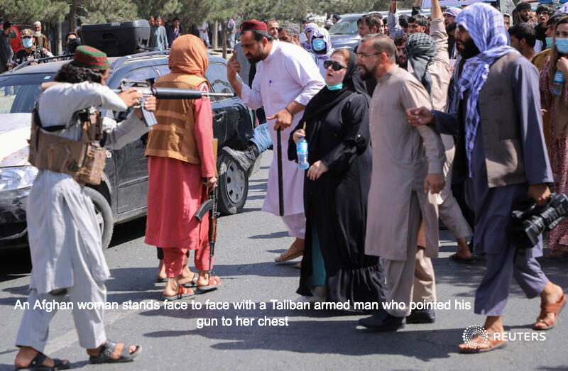

Figure 8: Afghan woman standing in front of Taliban gun
(Source:https://sg.news.yahoo.com/photo-afghan-woman-standing-front-101854177.html)

Afghanistan is not the country it was 20 years ago, and the people do not have the mentality they had 20 years ago. Tortures, executions, disappearances, targeted killings, beating of women and the people who oppose Taliban militants is not easy to hide in the age of internet and social media. The Taliban was an armed militant group until very recently, but now is a group that aspires to rule the state. It is trying to prove itself to the world of being capable of doing so. However, daily life of the Afghan people is marked by trampling on human rights. Thus, the seizure of power by the Taliban sets the country up for another, long-lasting war between the winners and the losers, fundamentalists and modernists, with no conciliation or compromise seems possible. After more than forty years, the civil war seems to be left in the past, however, the social war continues, and will probably last for several generations. Finally, the history has proven that it is impossible to negotiate and make agreement with the Taliban. Whatever commitments they make, they never respect them in the long run. (Rashid, 2010)

Humanitarian Situation / Famine Crisis

The political crisis in Afghanistan is coupled with a humanitarian crisis, fueled by drought, the Covid-19 pandemic and decades of war. 22.8 million people in Afghanistan are faced with acute famine crisis, and an “estimated 3.2 million children under the age of five are expected to suffer from acute malnutrition by the end of the year.” (UNICEF, 2021) According to UNICEF, at least one million children are facing imminent death without immediate treatment. Briefing the UN Human Rights Council, Nada Al Nashif, UN Deputy High Commissioner for Human Rights detailed how grave humanitarian crisis in Afghanistan jeopardizes basic rights, with civil society, particularly young women, among those most affected. Despite a widespread amnesty announced by the Taliban in August 2021, the UN has received ‘credible allegations’ of more than 100 people close to the former Government, including former Afghan national security forces, being killed. (UN Web TV, 2021)

The Taliban's extrajudicial killings of former security forces were also reported by Human Rights Watch. The 25 page report No Forgiveness for People Like You. Executions and Enforced Disappearances in Afghanistan under the Taliban, ”documents the killing or disappearance of 47 former members of the Afghan National Security Forces (ANSF) – military personnel, police, intelligence service members, and militia – who had surrendered to or were apprehended by Taliban forces between August 15 and October 31. Human Rights Watch gathered credible information on more than 100 killings from Ghazni, Helmand, Kandahar, and Kunduz provinces alone”. (Human Rights Watch, 2021) According to UN, since August, at least two reporters and eight human rights activists have been killed by armed man and many others injured. UNAMA, the UN mission in Afghanistan, has documented close to 60 cases of beatings, arbitrary detentions, and threats made to reporters, human rights activists, and the Afghanistan Independent Human Rights Commission staff. A number of women's rights supporters have also received threats, and there is widespread fear of retaliation since the women's peaceful protests in September have been violently suppressed. Numerous media channels have been shuttered, as well as civil society groups. (UNAMA, 2021)

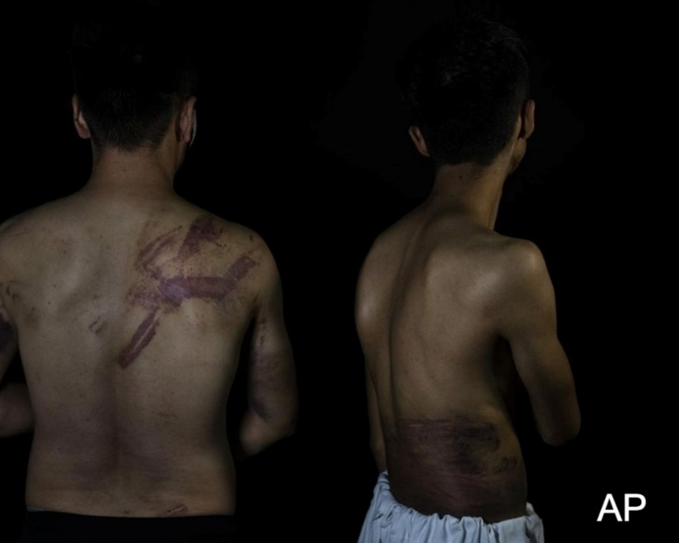

Figure 9: The Afghan reporters were detained and beaten by Taliban forces after covering a women's protest in Kabul.
(Source: https://www.poynter.org/newsletters/2021/journalists-in-afghanistan-were-beaten-while-covering-protests/)

As Nashif said, the Afghan people nowadays face a grave humanitarian crisis that jeopardizes the fundamental human rights. Crippling economic life is coupled with the crash of the banking system and a severe liquidity crisis. With the arrival of winter, the young and elderly people face severe poverty, famine, poorly available public services, particularly health care. The Afghans have been struggling to meet basic human needs, vulnerable groups, notably women and children – are compelled to reach out for desperate measures, including child labour, children marriages, even sale of children to ensure their survival. (UN Web TV, 2021) Afghan people is pushed to choose between dignity and deprivation, between life and death. And the justice is on lockdown.

Women and girls

The Taliban takeover the control of the country had a serious impact on many elements of the society. Still, the two groups are the most seriously affected: women and children, especially young girls. Women are among the priority targets of the Taliban doctrine. Women who have gradually acquired rights over the past twenty years have seen the new masters of the country destroying, in just a few hours, the progress they have made. They deeply fear that they will no longer be able to work or study and that they will be forced into marriage; some fear for their lives. However, Afghan women have made it clear that they want their education, their health care, and that they are ready, willing and able to design programs so that they can lead their communities. (Smith et al., 2020)

Here is the interview that one of the authors, Mustafa Bag, conducted with Aisha Ahmad: “What Afghan women demand from international community, especially during the Taliban administration:”

“As everyone knows, twenty years ago, during the Taliban rule, women were deprived of all human rights. With the fall of the Taliban and the arrival of international forces, the window of hope for the future of Afghan women and girls opened. School gates for girls were open and favorable conditions have been established for women to work in various fields, including political, economic, educational, cultural, arts, and sports. I feel very lucky to be born a year before the Taliban were removed from Kabul in 2001. I had a chance to attend high school and the university without any restrictions. Women, as half of society, have found their way into parliament and the judiciary, and have made progress in these areas. Girls like boys have found a place for themselves in higher education institutions and have made significant progress in the last twenty years. With the second arrival of the Taliban in Kabul and the consolidation of their power in the country, the fragile hopes of women and girls vanished one more time, and we became the first malicious and extremist target of the Taliban as if the Taliban had been fighting for 20 years to house Afghan women. High schools and universities gates were closed to girls, we were barred from going to public and private offices on the pretext that conditions were currently unfavorable for the women. By deceiving the international community, the Taliban are pushing for a plan to start schools and universities, 100 days after the beginning of their rule, but their plan has not yet been implemented. At the same time, the experience of the previous Taliban regime shows that considering their extremist way of thinking and their particular interpretation of Islam, they will never be willing to accept the active participation of women and girls in social, economic, political, administrative, educational and other areas of lives. By announcing an interim government to the world, the Taliban have become in charge of everything. They give false hope that in the future, with the formation of a permanent government, everything will return to normal. However, only people affiliated with the Taliban are appointed to government positions, no one else, and not a single woman. All working women and girls above the sixth grade, including university students, stayed at home, some of them began to beg. I as a third-year student of Kabul University stayed at home for months, was feeling very pressured even when going to visit a doctor or going outside. The Taliban, under pressure from public opinion and the international community and eager to gain international legitimacy, opened the gates of schools to girls above the sixth grade for a short time in some provinces, but were soon forced by their more extremist sections to close the gates again. We found ourselves deprived of normal and dignified life since the Taliban came to power. We have staged protests in various provinces demanding the restoration of our basic human rights, but the protests were severely repressed by the Taliban and we ended up being threatened with death. Afghan women activists were killed and the Taliban are still searching for and suppressing women and girls activists who want to speak out for their rights, including myself. Recently, the Taliban have made the presence of women in the media conditional on their own circumstances and have linked their continued work to wearing the hijab and other conditions. Not only has there been no specific reaction from the international community, but some countries are seeking to open the door to dialogue and negotiation for their diplomatic presence in Kabul in various ways by circumventing their moral obligations and human values on human rights. This, unfortunately, makes the Afghan women disappointed regarding credibility and the commitment of the countries to basic women’s rights. We as women of Afghanistan want the civilized world NOT to sacrifice the fate of half of the thirty-five million Afghanistan people for the sake of their economic interests and ask the world NOT to recognize a regime in the country that is not committed to any of the humanitarian values so that their next generations won’t have to apologize from the people of Afghanistan, but it will be very late, like today the international community regrets their late actions towards the people of Rwanda. We deserve compassion as women and girls in the rest of the world. We have the right to live a fearless life like everyone else. We have not committed any crime in the last twenty years in keeping with the caravan of human progress and civilization together with the international community so to be punished by the medieval Taliban today.”

Unfortunately, the abandonment of the Afghans, especially women, and leaving them to fate that no one would wish on their worst enemy, is confirmed: famine, cold, obscurantism, confinement has become commonplace in Afghanistan.

Where are the Women in Afghanistan Today?

Definitely not in the all-male Taliban government with abolished Ministry of Women's Affairs and no gender equality in universities…Since taking power, the Taliban have increasingly threatened women's rights, despite their promises to be more moderate and inclusive. This is a new blow to women's rights, which have been constantly violated since the Taliban came to power on August 15, despite the international community repeated warnings that the Taliban will be judged on their treatment of women and girls. As soon as they arrived in Kabul they replaced the Ministry of Women's Affairs with the Ministry of Promotion of Virtue and Prevention of Vice, which was responsible for enforcing sharia law in the public space during the first Taliban rule (1996-2001).

At the time, the religious police publicly beat women if their wrists, hands or ankles were undressed, if they did not wear sufficiently opaque socks, or if they were not accompanied by men. Girls' education was forbidden and misbehavior could result in stoning or execution. Women are gradually disappearing from the public space. Many of them have stopped their activities to avoid violence and reprisals, some of which have already cost them. Most of the demonstrations in favor of women's rights have been repressed by the Taliban. (Masood, 2020) Another sign of the radical view of religion imposed by the Taliban is that only boys were allowed to return to high school, although Taliban government spokesman said that girls will be able to return to school as soon as possible. The end of co-education in universities was also announced. In the future, female students will be separated from men by a curtain and will have to comply with strict dress codes. According to UNICEF, this will jeopardize the immense progress made in education over the past twenty years. (2021)

Women employed by the government offices were ordered to stay at home. Only those who cannot be replaced by men will be allowed to return to work. Despite the myriad threats to their rights, some women still continue to demonstrate across the country. The banning of rallies by Kabul's new masters was not enough to dampen the momentum of mobilization. From time to time activists gather in front of the former Ministry of Women's Affairs building to denounce discrimination in education and demand more inclusion in the government. (Gannon, 2021)

While the Taliban have long assured that women would have a place in society, their immediate measures have kept them away from education, work and the street. During the early Taliban rule, women were largely excluded from public life too. They could only leave their homes if accompanied by a chaperone. Officers of the Ministry of Virtue Promotion and Vice Prevention were known to whip women who walked alone. They were also responsible for strictly enforcing rigid interpretations of Islam, such as the obligation to attend prayers and the prohibition of shaving for men. At the time of the writing this article the Taliban introduced new restrictions on women. According to new ‘religious guideline', in the latest rollback of women's freedom, TV networks stopped broadcasting shows featuring female actors. As Khaled Hosseini, in his book “A Thousand Splendid Suns” said, "A society has no chance of success if its women are uneducated..." (2007, 231)

Families are Selling their Children

Since the Taliban retake of power, the country has been in the grip of a serious humanitarian crisis. As a result, families started selling their young children. Behind almost every door in the country, a similar situation; hunger crisis… The crisis in Afghanistan is greater than ever, coupled with drought and Covid-19. Humanitarian convoys cannot reach all areas of the country, and some families are forced to sell their children in order to buy food. The situation in the IDP camps have deteriorated gradually in recent months, and assistance for basic needs is almost never provided. Famine, unemployment, financial inability, deprivation of education of children and the lack of health services are among the biggest problems in the camps, where hopes for the future almost completely vanished. In recent months, especially families living in IDP camps have been selling their 3, 5, 7, 8, 10-year-old daughters for little amount like a thousand or thousand and two hundred dollars. Although there are many specific examples, we will not give names for the sake of the protection of human dignity and the privacy of children. However, the world witnessed a 9-year-old girl being forcibly sold to a 55-year-old man in a refugee camp in the western part of the country. The video of the little girl being dragged out of the door of the house by her new 'husband' is one of the most obvious examples of what Afghan girls go through. The news was widely covered by the international media.

The sale of young girls is not just happening in Afghanistan. The same occurs in the neighboring Pakistan. Many poor families in Pakistan continue to sell their daughters for small amount of money. Another example of similar practice is Myanmar and Vietnam. It is frequently featured in the international media that human smugglers earn large amounts of money from this trade. Some of the girls sold as brides were later used as sex slaves. A study conducted by AP news agency, revealed that hundreds of Pakistani girls were sold to China. (Gannon, 2019) CNN’s report, titled, “Vietnamese girls smuggled into China and sold as child brides” shed light on another human smuggling issue. The news article revealed that thousands of girls from Vietnam were sold to China or other countries under the name of brides. (Boykoff & Field, 2016)

On the other hand, early marriage was common in Afghanistan before the current crisis that has left half the country food insecure. Overall, 28 percent of Afghan girls are married before they reach the age of eighteen, and about four percent before their 15th birthday. (Fore, 2021) However, stories of girls being sold in the cradle or before reaching puberty are not new. This practice is especially evident during humanitarian crisis and has been practiced in Afghanistan for centuries. Today, war and climate-related poverty drive many families to make agreements about future wives - agreements made earlier and earlier in the lives of girls. In addition, a cultural context prevails in Afghanistan where early marriages are rooted in the culture, traditions and religion. (Barfield, 2012)

In Afghanistan, the humanitarian catastrophe already exists and could become one of the worst in its already tormented history. The re-emergence of the Taliban is not only due to its current political effects; It should be considered together with its long-term effects that shape the generations that will grow up in Afghanistan in the near future and the mentality that will be shaped. The question is who will replace the Taliban, once removed from power, in an environment where the hostilities between ethnic groups and different sects continue? In fact, the Afghans themselves do not know the answer to this question. If there is anything more dangerous than the Taliban in Afghanistan, it is ethnic nationalism. Pashtun, Tajik, Uzbek, Turkmen, Hazara, Pashai, Noristani and many other ethnic groups live in Afghanistan. (Smith et al., 2020) So, is a federalism system possible? Afghans oppose this notion, although they fail to come together. In addition, one of the most important reasons for the instability in Afghanistan is Pakistan's unconditional support of the Taliban. (Zahab, 2020)

Conclusion

Since the collapse of the Soviet Union, the U.S. has created an expanded defensive line that was established after World War II. That line stretches from Romania, through Central Eurasia to Israel, Afghanistan and Pakistan. The United States has decided to put the region between industrialized China and India, recovered Russia and united Europe under its military security umbrella. The 'war on terror’, launched as a response to the 9/11 terrorist attacks, resulted in the invasion of Afghanistan, which the United States considered a geopolitical gateway (and an important pipeline route) to Central Asia and the Caspian Basin, followed in 2003 by invasion of Iraq.

It is more than obvious that the American war on terrorism, i.e. the threats posed by Iraq, Iran and Afghanistan, cannot be separated from the historical oil exploitation by Western countries in this region. The Iranian revolution and the Soviet invasion of Afghanistan were interpreted as attempts to take control of the Persian Gulf region and at the same time attack on vital American interests, which the United States defends by all means, including, of course, the military ones. Both actions were believed to pose a threat to the U.S. ability to ensure unhindered access to Gulf oil. "The region now threatened by the Soviet troops in Afghanistan is of great strategic importance," (Carter, 1980) Carter said in his famous address, adding: "It holds more than two-thirds of the world's oil reserves." (Ibid) What was of a particular concern at the time to the American political and military establishment is the fact that: "The Soviet Union's efforts to dominate Afghanistan brought Soviet forces 500 kilometers from the Indian Ocean and very close to the Strait of Hormuz, the waterway that carries most of the world's oil." (Ibid) The Americans believed that the Soviet Union attempted to reinforce its strategic position, posing serious threat to the oil transport coming from the region of the Middle East.

In other words, powerful energy and economic interests are the driving force behind American defense policy. Concerns about the security of vital resources have long been a central feature of American strategic planning. Pentagon strategy planners believe that securing U.S. primacy in the global competition for resources must be a primary priority of U.S. military policy. For this purpose, the relocation of American military bases was carried out. During the Bush Administration most of the major military bases were located in Western Europe, South Korea and Japan. However, the Pentagon very quickly began moving them from the outer edges of Eurasia to its central and southern parts, as well as Central and Eastern Europe, and North and Central Africa. True, some of these regions host al-Qaeda, as well as fragile Middle Eastern states, but they contain more than 80 percent of the global oil and gas reserves. The map of terrorist refuges and targets in Central Asia and the Middle East largely coincides with the map of the world's major energy sources in the 21st century. Inevitably, many will see the war on terror as a war on behalf of British Petroleum, Royal Duch Shell, Chevron, Exxon and other multinational giant companies, which have invested hundreds of billions of dollars in these regions. More precisely, the hidden motive of the war on terrorism is oil.

Former Bush’s speech writer David Frum wrote in 2003: "The war on terror is designed to bring stability to the most volatile part of the world and prosperity to all of us by providing the world's largest source of oil." (Juhasz, 2008, 321) On the other hand, war in Afghanistan, among other goals, was to solve the problem of extracting oil from the Caspian Basin, finally giving the long-awaited chance for the American companies to build a pipeline that would transport oil from this region through Afghanistan and Pakistan to the Indian Ocean. However, the Taliban insurgents and the overall instability in Afghanistan made it impossible to achieve this goal. Afghanistan itself, even without significant natural resources, is a key bridge connecting Central Asia, Iran, Pakistan, the Indian subcontinent and Southeast Asia. In this context, it is important to emphasize that the invasion of Afghanistan was an opportunity for the Bush administration to implement a project made immediately after the collapse of the Soviet Union. The military presence in the heart of the Eurasian continent, which connects Russia and China - two countries moving towards allied relations to more effectively resist American hegemonic pressure, or even allied relations with Iran - had obvious geostrategic value.

The central goal of the war in Afghanistan, in addition to destroying the al-Qaeda network, was in fact strategic implantation in Central Asia and on the shores of the Caspian Sea - areas used as a springboard for military operations in Iraq and Afghanistan. This explains Washington's low level of interest in controlling the internal situation in Afghanistan or in building a promised modern state. The United States knows very well that the stakes in Afghanistan are too small to justify the huge financial and military investments necessary to bring this country under control without any guarantee of success. The war against the Taliban-al-Qaeda alliance, in fact, gave America the opportunity to carry out the expansion of its imperial military network.

“From the breakup of the former Yugoslavia and various post-Yugoslav wars to the US / NATO response to numerous political and economic crises in the post-Soviet space and the recent war on terror in Afghanistan - all are linked by one motive: resource allocation and politico-military control of Eurasia.”

BIBLIOGRAPHY
Aamer Madhani, A. & Z. Miller. (2021). “War is over but not Biden’s Afghanistan challenges”, Associated Press,https://apnews.com/article/europe-afghanistan-3684fd02c4bdc7c062cc7a141f720e72
Abou Zahab, M. (2020). Pakistan: A Kaleidoscope of Islam. Oxford University Press, https://www.amazon.fr/Pakistan-Kaleidoscope-Mariam-Abou-Zahab-ebook/dp/B08645Y1YW
Ahmad, M. (2020). Afghanistan: The Journey of State Building and Democracy. Austin Macauley Publishers Ltd.
AP, “A timeline of U.S. troop levels in Afghanistan since 2001”, 2021, Military Times. https://www.militarytimes.com/news/your-military/2016/07/06/a-timeline-of-u-s-troop-levels-in-afghanistan-since-2001/
Bag, M. (2019). "Afganistan'da Sovyetler Birliği işgalinin bitişinin 30'uncu yıl dönümü". Euronews.com, https://tr.euronews.com/2019/02/15/sovyetler-birligi-nin-afganistan-isgalinin-bitisinin-30-uncu-yil-donumu
Barfield, T. (2012). Afghanistan – A Cultural and Political History. Princeton University Press.
Bearden, M. (2001). “Afghanistan, Graveyard of Empires”. Foreign Affairs, https://www.foreignaffairs.com/articles/afghanistan/2001-11-01/afghanistan-graveyard-empires
Biden, J. (2001). “Remarks by President Biden on Afghanistan”. The White House https://www.whitehouse.gov/briefing-room/speeches-remarks/2021/08/16/remarks-by-president-biden-on-afghanistan/
Boykoff, P & Alexandra Field (2016). "Vietnamese girls smuggled into China and sold as child brides". CNN https://edition.cnn.com/2016/04/17/asia/vietnamese-girls-child-brides-china/index.html
Carter, J. E. Jr. (1980). State of the Union Address, The Capitol, Washington, D.C.http://www.airforce-magazine.com.
Chandrasekaran, R. (2013). Little America: The War Within the War for Afghanistan. Vintage.
Delalić, S. & A. Olovčić. (2022). Politics and War in Historical and Theoretical Perspective. With EU Case Study. Anuario Español de Derecho Internacional, https://doi.org/10.15581/010.38.161-214
Dorronsoro, G. (2001). "The World Isolates the Taliban", 2001, Global Policy Forum, https://archive.globalpolicy.org/the-dark-side-of-natural-resources-st/water-in-conflict/41438.html
Edwards, D. B. (2002). Before Taliban. University of California Press.
Fore, H. (2021). Girls increasingly at risk of child marriage in Afghanistan. UNICEF,https://www.unicef.org/press-releases/girls-increasingly-risk-child-marriage-afghanistan.
Gannon, K. (2019). “629 Pakistani girls sold as brides to China”, AP https://apnews.com/article/ap-top-news-pakistan-international-news-weekend-reads-lahore-c586d0f73fe249718ec06f6867b0244e
Gannon, K. (2021). “Taliban form all-male Afghan government of all guard members”. Associated Press,https://apnews.com/article/middle-east-pakistan-afghanistan-arrests-islamabad-d50b1b490d27d32eb20cc11b77c12c87.
Gates, R. (n.d.). From the Shadows: The Ultimate Insider’s Story of Five Presidents and How They Won the Cold War. S&S International.
Goodson, L. (2003). "Afghanistan's Long Road to Reconstruction", Journal of Democracy.
Gossman, P., Adams, B. Ross, J., Saunders, J., Legerwood, R., Carr, T., Martinez, J. & Fitzroy Hepkins. (2021) “Executions and Enforced Disappearances in Afghanistan under the Taliban”. HRW, https://www.hrw.org/report/2021/11/30/no-forgiveness-people-you/executions-and-enforced-disappearances-afghanistan
Hammond, P. (2012). “Communist Liberation - Myth & Reality”. Frontlinemissionsa, https://www.frontlinemissionsa.org/persecution/communist-liberation-myth-reality
Harry G. Barnes, Jr., Whitley, A. & Patricia Gossman, (1991). "Afghanistan: The Forgotten War: Human Rights Abuses and Violations of the Laws of War Since the Soviet Withdrawal". Refworld https://www.refworld.org/docid/45c9a5d12.html
Hosseini, K. (2013). The Kite Runner. Bloomsbury Publishing PLC.
Ingram, B. D. (2009). "Sufis, Scholars and Scapegoats: Rashīd Aḥmad Gangohī and the Deobandi Critique of Sufism". The Muslim World. https://www.academia.edu/282790/Sufis_Scholars_and_Scapegoats_Rashid_A%E1%B8%A5mad_Gangohi_D._1905_and_the_Deobandi_Critique_of_Sufism
Isby, D. (2010). Afghanistan: Graveyard of Empires. Pegasus books.
Juhasz, A. (2008). The Tyranny of Oil: The World's Most Powerful Industry and What We Must Do To Stop It. HarperCollins Publishers Ltd.
Kalyvas Stathis N. (2006). The Logic of Violence in Civil War. Cambridge University Press.
Khalilzad, Z. & Rand Corporation. (1991). Prospects for the Afghan interim government. Santa Monica, CA: Rand.
Kipling, R. (2011). The Great Game. Ohio State University library, https://guides.osu.edu/c.php?g=300070&p=7043825
Kissinger, H. (1994). Diplomacy. Simon & Schuster.http://ijevanlib.ysu.am/wp-content/uploads/2020/05/1f6300e67784b164a9857efd25ed325b.pdf
Kissinger, H. (2021). Henry Kissinger on why America failed in Afghanistan, The Economist, https://www.economist.com/by-invitation/2021/08/25/henry-kissinger-on-why-america-failed-in-afghanistan
Knickmeyer, E. (2021). Costs of the Afghanistan War, in lives and dollars, AP News, https://apnews.com/article/middle-east-business-afghanistan-43d8f53b35e80ec18c130cd683e1a38f.
Malkasian, C. (2021). The American War in Afghanistan: A History. OUP USA.
Mantoo, S. (2021). “UNHCR warns Afghanistan’s conflict taking the heaviest toll on displaced women and children”, 2021, UNHCR https://www.unhcr.org/news/briefing/2021/8/611617c55/unhcr-warns-afghanistans-conflict-taking-heaviest-toll-displaced-women.html
Neta C. Crawford and Catherine Lutz, “Human Cost of Post-9/11 Wars: Direct War Deaths in Major War Zones, Afghanistan & Pakistan (Oct. 2001 – Aug. 2021); Iraq (March 2003 – Aug. 2021); Syria (Sept. 2014 – May 2021); Yemen (Oct. 2002-Aug. 2021) and Other Post-9/11 War Zones”, 2021, Watson Institute), https://watson.brown.edu/costsofwar/
North Atlantic Treaty Organization. (2022). Resolute Support Mission in Afghanistan 2015-2021, https://www.nato.int/cps/en/natohq/topics_113694.htm
PBS News Desk. (2011). "A Historical Timeline of Afghanistan", https://www.pbs.org/newshour/politics/asia-jan-june11-timeline-afghanistan
Rashid, A. (2010). Taliban: Militant Islam, Oil and Fundamentalism in Central Asia. Yale University Press.
Read, R. (2009). "In midst of war, Rumsfeld didn't know who the 'bad guys' were in Afghanistan and Iraq". Washington Examiner. https://www.washingtonexaminer.com/policy/defense-national-security/in-midst-of-war-rumsfeld-didnt-know-who-the-bad-guys-were-in-afghanistan-and-iraq
Smith, S., Yusufzai, M. & Ahmed Mengli. (2020). "Corruption, conflict and a common enemy: Can old Afghan opponents come together to make peace?", 2020, NBC, https://www.nbcnews.com/news/world/corruption-conflict-common-enemy-can-old-afghan-opponents-come-together-n1242382
Sopko, J. (2021). “HAT WE NEED TO LEARN: Lessons from twenty years of Afghanistan reconstruction”, SIGAR https://www.sigar.mil/pdf/lessonslearned/SIGAR-21-46-LL.pdf
State Department. (2020). “Agreement for Bringing Peace to Afghanistan”. https://www.state.gov/wp-content/uploads/2020/02/Agreement-For-Bringing-Peace-to-Afghanistan-02.29.20.pdf
Steve Coll and James Rupert, "Kabul street battle continue", 1992, Washington Post https://www.washingtonpost.com/archive/politics/1992/04/28/kabul-street-battles-continue/41854220-a9dc-4445-8947-e3ac5da0ca76/
The Guardian. (2022). No disciplinary action for US troops over Kabul drone airstrike, https://www.theguardian.com/world/2021/dec/13/kabul-airstrike-pentagon-drone-no-disciplinary-action#:~:text.
UN. (2021). “Registered Refugees from Afghanistan (in Iran, Pakistan, Tajikistan, Uzbekistan, Turkmenistan)”, UNHCR https://data2.unhcr.org/en/situations/afghanistan#_ga=2.93949597.1407201374.1640829126-378000056.1640623868
UNICEF. (2021). Half of Afghanistan’s children under five expected to suffer from acute malnutrition as hunger takes root for millions,https://www.unicef.org/press-releases/half-afghanistans-children-under-five-expected-suffer-acute-malnutrition-hunger.
UNICEF. (2021).“Providing quality education for all”. https://www.unicef.org/afghanistan/education
Vince, C. (2021). "Guerre froide : causes, développement, dates... Résumé des événements". Linternaute.com https://www.linternaute.fr/actualite/guide-histoire/1788277-guerre-froide-staline-kennedy-mao-ces-leaders-qui-ont-change-le-monde-chronologie/
Whitlock, C., Shapiro L. & A. Emamdjomeh. (2019). “A Secret History of the War”. WashingtonPost,https://www.washingtonpost.com/graphics/2019/investigations/afghanistan-papers/documents-database/

https://www.whitehouse.gov/briefing-room/speeches-remarks/2021/08/31/remarks-by-president-biden-on-the-end-of-the-war-in-afghanistan/
The borrowing interest is expected to reach 6.5 trillion dollars by 2050.
Definition of chaperone by Cambridge Dictionary: „an older person, especially a woman, who stays with and takes care of a younger woman who is not married when she is in public.“

